ATAR Physics 11

Unit 1

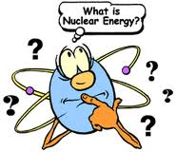

Nuclear Energy

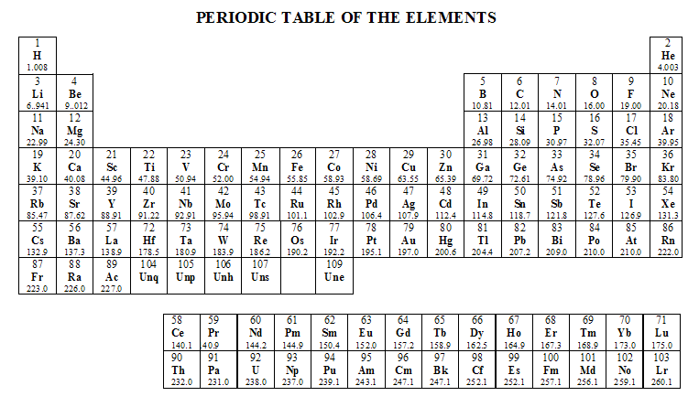
Atomic Masses of some common atoms:
Please Note: These values are taken from Exploring Physics from STAWA. The values for a proton, neutron and alpha particle are different from the values given in the Curriculum Council data sheet. Students need to use the values given to them in the problem or data sheet they are supplied with for tests and examinations.

Isotope | Atomic mass (u) | Isotope | Atomic mass (u)
Neutron  Proton  Hydrogen-1  Hydrogen-2  Hydrogen-3  Helium-3  Helium-4  Lithium-7  Carbon-12  Carbon-14  Nitrogen-14  Oxgyen-16 | 1.00867  1.00728  1.00783  2.01355  3.01605  3.01603  4.00260  7.01601  12.00000  14.00324  14.00307  15.99943 | Oxygen-17  Krypton-92  Iodine-131  Barium-141  Xenon-142  Gold-198  Mercury-198  Thorium-234  Uranium-235  Uranium-238  Plutonium-239 | 16.99913  91.92616  130.90613  140.91441  141.92971  197.96824  197.96677  234.04360  235.04393  238.05079  239.05216

Constants:
- 1u = 931 MeV
- 1 MeV = 1.6 x 10⁻¹³ J
- 1 u = 1.6606 x 10⁻²⁷ kg
- speed of light, c = 3.0 x 10⁸ ms⁻¹

Quality Factors
Alpha particles 20
Fast neutrons 10
Slow neutrons 3
Beta particles 1
Gamma rays 1
X-rays 1

Nuclear Physics: An Introduction

- Nuclear energy is the release of energy from the nucleus when atoms are split (fission) or fused (fusion).
- As yet we don’t have the technology to run nuclear fusion power plants however fission power plants are common throughout the world as they are inexpensive, create no air pollution (unlike burning fossil fuels) and produce a large amount of energy.
- They do have one major problem though – nuclear waste.

- Burning fossil fuels is a result of changes in the electrons involved in the reaction (nucleus is not changed), atoms remains the same in reactants and products.
e.g. 2C₄H₁₀ + 13O₂ 8CO₂ + 10H₂O + energy, or about 1.6 kilowatt-hours per kilogram of carbon is released as heat.

- Nuclear energy however involves changing the atomic structure of the atoms and hence new elements are created
e.g. + energy, about 18.7 million kilowatt-hours per kilogram of uranium-235 is released as heat, a massive difference in the energy produced.
- Obviously the difference in the energy produced is due to the changes that occur to the atoms within the reaction; therefore an understanding of the atom is essential.
The nuclear model of the atom describes the atom as consisting of an extremely small nucleus which contains most of the atom’s mass, and is made up of positively charged protons and uncharged neutrons surrounded by negatively charged electrons

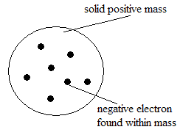
Development of the Models of the Atom

- Sir Joseph John Thomson had the first recognized model of the atom known as the “Plum Pudding” model.
- In 1899 he stated that the atom was a solid positive mass with the negative electrons (discovered by him in 1987) embedded within it.

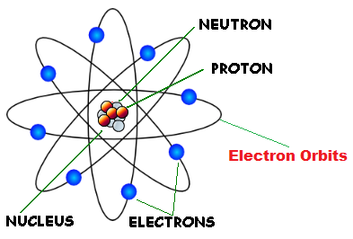
- Ernest Rutherford’s model (1911), in which electrons move around a tightly packed, positively charged nucleus, successfully explained the results of scattering experiments (see below), but was unable to explain discrete atomic emission—that is, why atoms emit only certain wavelengths of light.

Scattering Experiment: Experimental evidence for Rutherford’s model:
- Rutherford fired alpha particles (positive charge) into gold leaf (very thin gold sheeting). Most went through, a few were deflected and even fewer were reflected back again.
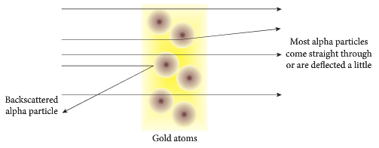
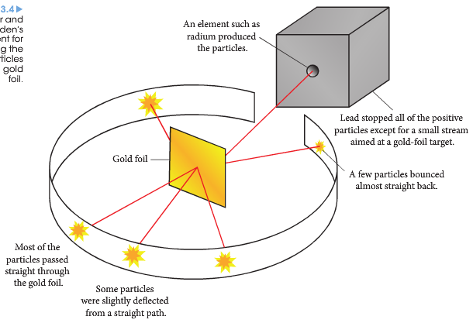

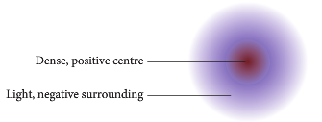

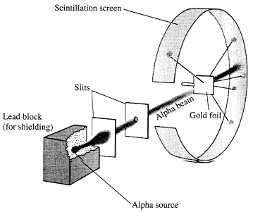
- What did this imply about the atom?

“Most went through”:

“Few were deflected”:

“Even fewer were reflected back”:

- James Chadwick discovered the neutron. He discovered that when beryllium was bombarded with positively charged alpha particles a beam with a high penetrating power was created.
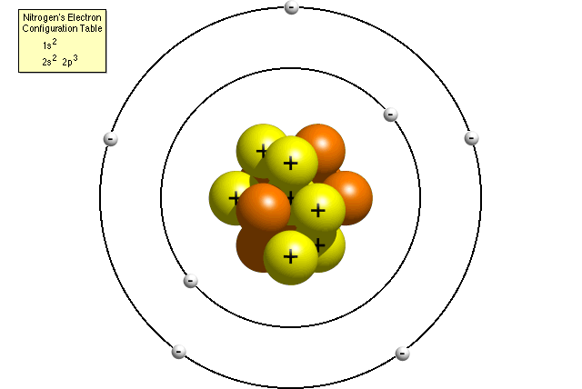
- This beam was not deflected by either electric or magnetic fields, meaning it contained neutral particles – neutrons.
- Neutrons were found to have the same mass as protons.

- Niels Bohr began with Rutherford’s model, but then postulated further that electrons can move only in certain quantised orbits.
- This model was explained certain qualities of discrete emission for hydrogen, but failed for other elements.

Structure of the Atom

- The atom is the smallest whole unit that can exist independently.

___________
(negative charge) ________ (positive charge)

______________ (no charge)
_______________
(area electrons are found)

__________________

- electron, negative charge – discovered by J.J. Thomson 1897
- proton, positive charge, in nucleus – discovered by Ernest Rutherford in 1919.
- neutron, no charge, in nucleus – discovered by Sir James Chadwick in 1932.
- proton and neutron have most of mass of atom and found in the nucleus
- electrons have about the mass of a proton or neutron and are found in the electron cloud around the nucleus.

Atomic Number and Mass Number

- The Atomic Number (Z) is equal to the number of protons in the atom and gives the atom its place on the periodic table.
- The Mass Number (A) is equal to the total sum of the neutrons and protons in an atom.
- The following convention is used to show the structure of an atom, this is also known as a nuclide.

where X stands for the element
A for the mass number
Z for the atomic number
- The nuclide for phosphorus-31 is:

The element is phosphorus, it is atomic number 15, has a mass number of 31.
It has 15 protons and 16 neutrons (mass number subtract number of protons)

- Atoms are different when their number of ____________ are different. The number of protons gives the atom its place on the __________ table. The number of protons is called the _________ NUMBER. In an uncharged atom, the number of electrons (negative charge) equals the number of protons (positive charge). The ________ NUMBER is the total number of ____________ plus ____________, hence the number of neutrons equals the mass number subtract the number of protons. All chemical reactions, such as burning fossil fuels, take place due to the movement of electrons. If an atom loses an electron it becomes ____________ charged. If it gains an electron it becomes ____________ charged. Atoms that have gained a charge are called ions. For Nuclear Physics we will only deal with atoms, ions are covered in Chemistry.

- Complete the following table:
Element | Symbol | Nuclide | Atomic Number  (Number of protons) | Number of neutrons | Mass Number (protons + neutrons)
Hydrogen | H |  | 1 | 0
Sodium | Na |  |  | 12 | 23
 |  |  | 17 |  | 35
 |  |  | 8 |  | 15

Isotopes
- A given nuclear species is called a nuclide.
- Two or more different nuclides of the same element are called isotopes.

- Isotopes:
- are nuclides of the same element (same atomic number and so same number of protons).
- differ in the number of neutrons they contain (in their mass number).
- have the same chemical properties but different physical properties.

- Oxygen-16 has 8 protons and 8 neutrons:
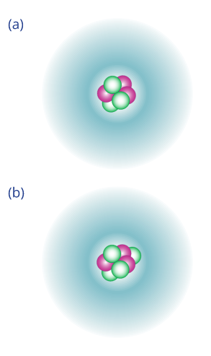
- Oxygen-21 has 8 protons and13 neutrons:


Two different isotopes of lithium:

⁷Li
⁶Li

- Complete the following table them determine which are isotopes of each other.

Element | Nuclide | Atomic Number | Number of neutrons | Mass Number
A |  |  | 7 | 14
B
C |  | 6 |  | 14
D |  | 7 |  | 13
E |  |  | 7 | 13

- The isotopes are:

- Most of the atoms around us are stable and their nucleus has remained stable since they were formed, in fact, many are billions of years old.

- Sometimes a nucleus is unstable either due to its size or general unstable nature of the atom.
- When these nuclides become unstable, they decay to more stable forms by either breaking into smaller elements or by emitting energy (gamma radiation) and/or particles (alpha and beta radiation) from the nucleus.

- Uranium decays to more stable Thorium: (alpha particle emitted)
- Excited barium loses energy to become stable barium. (gamma emitted)
Radioisotopes

- Radioisotopes are unstable isotopes of an atom.
- An example is carbon-14 which is a radioisotope of carbon-12.
- Radioisotopes can spontaneously decay to become more stable.
- Carbon-14 decays to nitrogen-14: note: is a beta particle so can be written
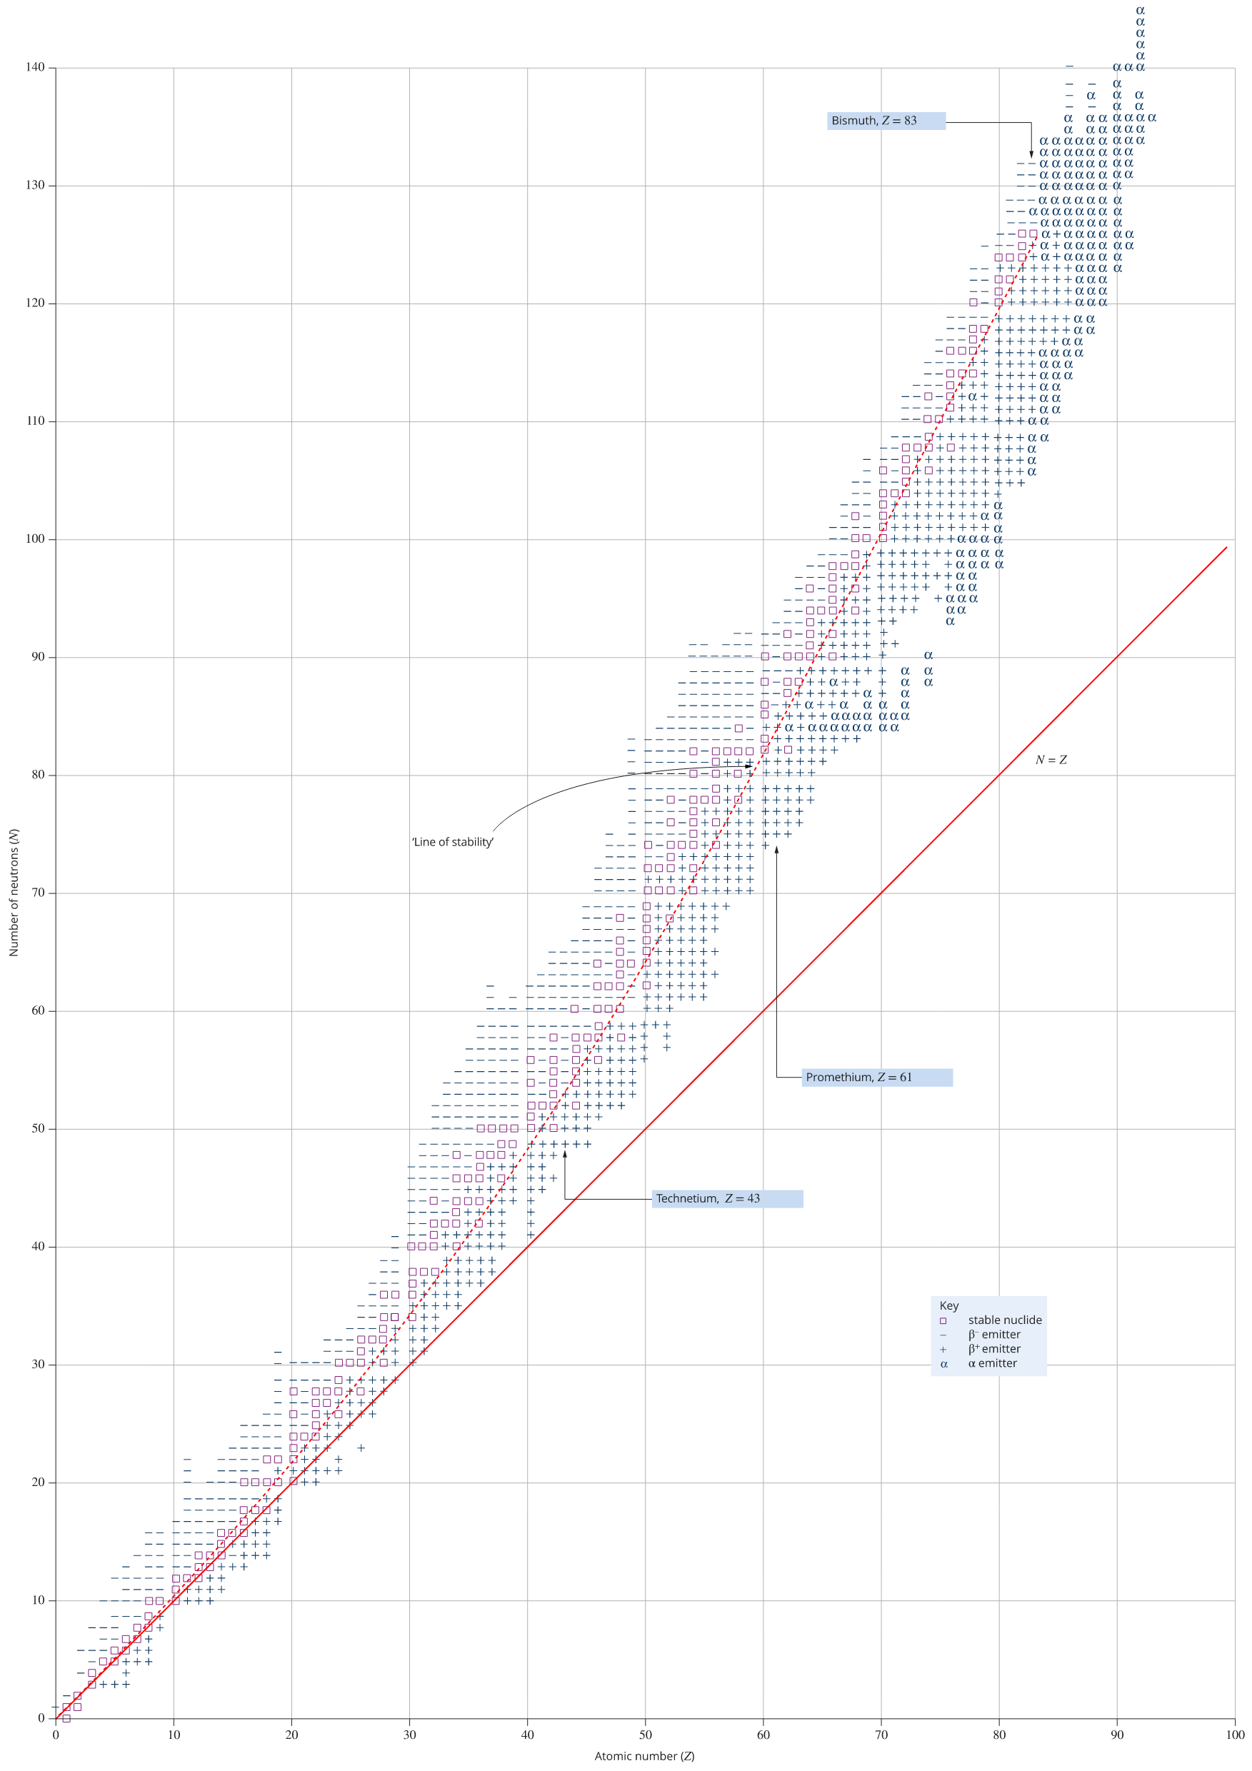
Chart showing stable and radioactive isotopes
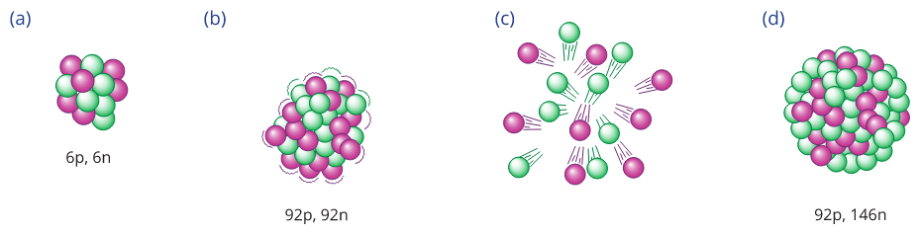

A small nucleus such as carbon-12 is stable. Repulsion is overcome by the strong nuclear forces.



A large nucleus with equal numbers of protons and neutrons cannot exist. Repulsion is too much for the strong nuclear forces.

Additional neutrons increase the stability of large nuclei. Extra neutrons increase the influence of the strong nuclear force, acting like a 'nuclear glue'.

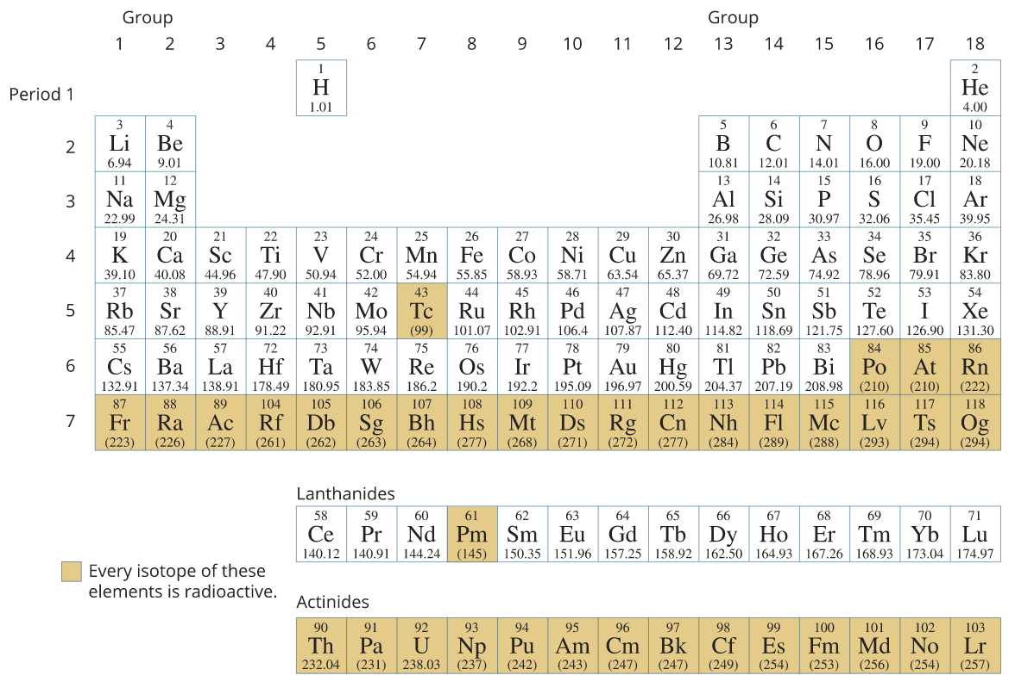

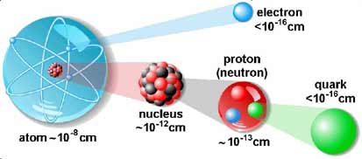
Going deeper into the atom (Year 12)
Quarks
- Quarks and Leptons are currently recognised as the fundamental particles of matter.
- There are six quarks and six leptons which are currently thought to be the building blocks of our universe.

- Quarks and leptons are separated according to their flavour (or type).
- Quarks are separated into three pairs: up / down, top / bottom, strange / charm
- Leptons are separated into: electron, muon, neutrino, tau, electron-neutrino, tau-neutrino
- An electron is a lepton.

- Quarks join together to form hadrons such as protons and neutrons.
- Quarks also have anti-particles called antiquarks and it is interesting to note that quarks and antiquarks are the only two fundamental particles that interact through all four fundamental forces of physics - strong nuclear forces, weak nuclear forces, electromagnetism and gravitational forces.

- Quarks have the unusual characteristic of having a fractional electric charge unlike protons and electrons.

- Up, charm and top quarks (referred to as up-type quarks) have +2/3 electric charge.
- Down, strange and bottom (referred to as down-type quarks) have -1/3 electric charge.
- The charge on a hadron is determined by the quarks that form it. For instance, a proton is made of an two up and one down quark: + - = +1 and as we know, the charge on a proton is +1.

Leptons

- There are six leptons, three of which have electrical charge and three of which do not.
- They are believed to be point-like particles without internal structure.
- The electron is a charged lepton. The other two charged leptons are the muon (μ) and the tau (τ), which are charged like electrons but have more mass.
- The other leptons are the three types of neutrinos (ν). They have no electrical charge, very little mass, and they are very hard to find.
- Unlike quarks, leptons are solitary particles and hard to see. For each lepton there is a corresponding antimatter antilepton. The anti-electron is given the name “positron” and has a charge of +1.
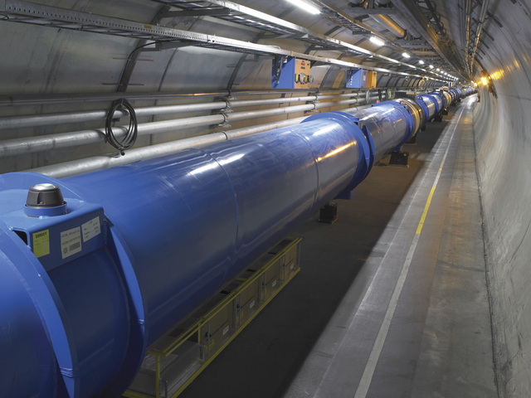
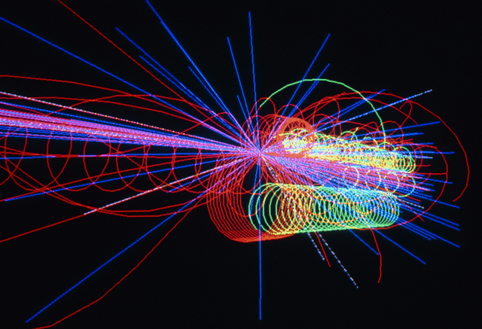
Nuclear stability is the result of the strong nuclear force which operates between nucleons over a very short distance and opposes the electrostatic repulsion between protons in the nucleus.

Particle accelerator at CERN (the European Organisation for Nuclear Research) in Switzerland
Collision of subatomic particles at CERN (the European Organisation for Nuclear Research) in Switzerland.
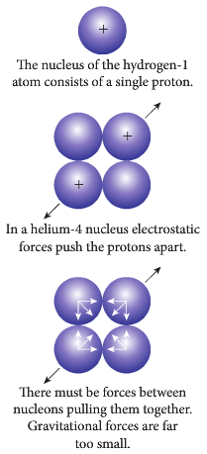
- Nuclear forces are the forces that hold all matter together. There are four basic forces in nature.

- The strong force acts between nucleons (protons and neutrons).
  - They bind protons and neutrons together.
  - This force is about 10 millions times stronger than the chemical bonding that holds atoms together in molecules.
  - They only act over a very small distance.

- The electromagnetic force enables atoms to from by the electromagnetic attraction between protons and electrons.
  - These forces can act over a large distance.
- The weak force is responsible for various kinds of radioactive decay.
  - The other forces are important in holding matter together, the weak force is important when things fall apart.
- The gravitational force acts on all matter over large distances.
  - It is the weakest force of the four.

- If gravity force had a value of 1, weak interaction would be 10²⁵, electromagnetic interaction would be 10³⁶ and strong interaction 10³⁸.

PP 3.1 p 46-53 3.1 Review p 54

Some nuclides are unstable and spontaneously decay, emitting alpha, beta (+/-) and/or gamma radiation over time until they become stable nuclides.

Nuclear Radiation
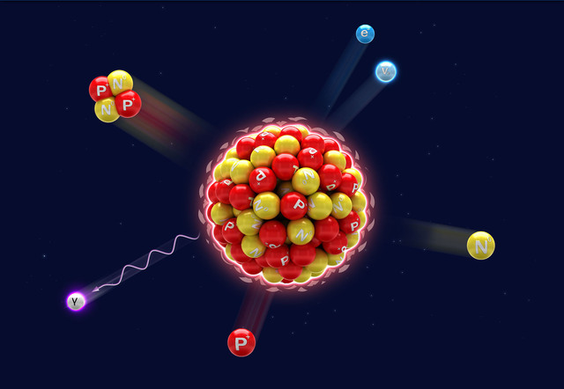
Types of radiation

- Radiation can be produced from the spontaneous disintegration of the nucleus of an atom.
- The nucleus releases particles or energy to become more stable.
- Common examples of the type of radiation produced are alpha, beta and gamma radiation:

- is like a helium nucleus and is called ________radiation, symbol ____
- is a high speed electron and is called ________ radiation, symbol ____
can be ____ or ____
electrons are emitted from the ________
- is ________ radiation, symbol _____
is ________________________
Alpha Radiation :
- Consists of two protons and two neutrons, like a helium nucleus.
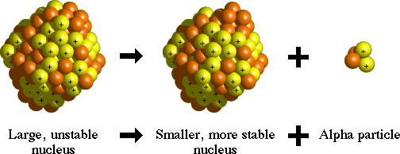
- As nucleus lost two protons, transmutes into new element.
- Very large mass compared to beta and travels at 1/10th the speed of light.

- Due to size and speed, alpha radiation can’t penetrate skin.
2 less protons


The wicks or mantles used in old-style camping lamps are slightly radioactive. They contain a radioisotope of thorium, an alpha-particle emitter.

- Beta Radiation or ${}_{+1}^{0}β$:
- Beta Radiation is made up of high speed electrons (or positrons) from inside the nucleus (not to be confused with the electrons that orbit the nucleus).

- Beta particles have a very small mass and travel close to the speed of light (3.0 x 10⁸ ms⁻¹).

- A neutron emits the beta particle becoming a proton thus changing the atomic number of the atom and producing a new element (transmutation).

- Beta particles can be negatively charged, β⁻, or positively charged, β⁺, (called positrons).

- If a β⁻ is emitted there is an increase in atomic number but if a positron is emitted, there is a decrease in atomic number.
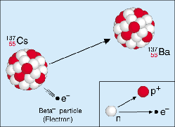
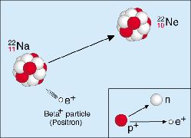

POSITRON ELECTRON

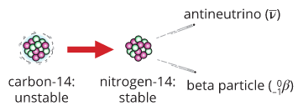
Beta-minus decay of carbon-14. An antineutrino is also released in the process.

- Due to their mass and speed (energy), beta particles can penetrate up to 2 cm into the human body.

- However, from our point of view, beta radiation is relatively safe and is used in the human body as a tracer.
- A beta emitting radioisotope is given to the patient by injection or swallowing and then its progress is monitored as it moves through the body.
- Beta is most commonly used to help in blood flow (or lack of), thyroid, and bone diseases, and tumour detection.

Gamma Radiation${}_{0}^{0}γ$:
excited more
state stable
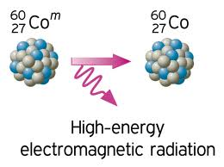
- Gamma radiation is electromagnetic radiation so is not a particle but energy.

- It is energy emitted from the nucleus when it undergoes radioactive decay.
- As it is energy, has no mass so no mass lost from atom and atom remains the same element.

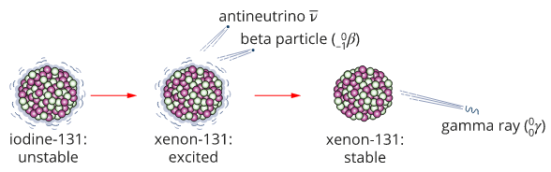
Gamma and beta decay of iodine-131

- As electromagnetic radiation, gamma radiation travels at the speed of light.
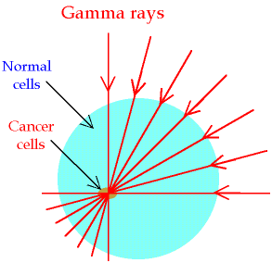
- It can pass through the human body and in small does not a major problem (we are struck by cosmic rays every day) unless the radiation strikes a cell’s DNA and causes mutations. This can then cause cancer.

- In large doses gamma radiation is lethal as it affects the body’s organs and causes them to shut down.
- On the positive side, gamma radiation is also used to kill cancerous cells. A thin beam of gamma radiation is directed at the tumour as the source is continually rotated around the patient.

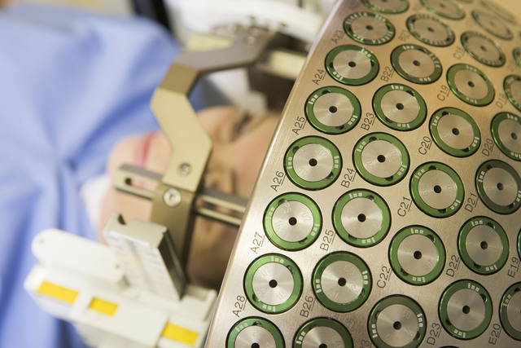
Gamma ray helmet containing radioactive sources that destroy cancer cells

PP 3.2 p 55-60 3.2 Review p 61

Alpha, beta and gamma radiation have different natures, properties and effects.

Alpha (α), Beta (β) And Gamma (γ) Radiation
- Radioactivity is the spontaneous disintegration of atomic nuclei by the emission of subatomic particles called alpha particles and beta particles, or of electromagnetic radiation called gamma radiation.

- Each form of radiation has different properties due to their different masses, speeds and charge.

- They will have different penetrations through materials and different abilities to ionise materials.

Penetration of α, β and γ.

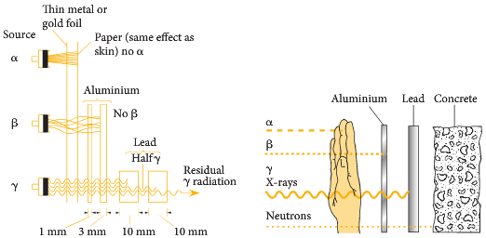

Effect of magnetic field
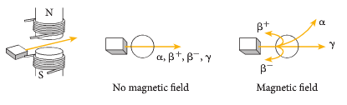
Properties of of α, β and γ.

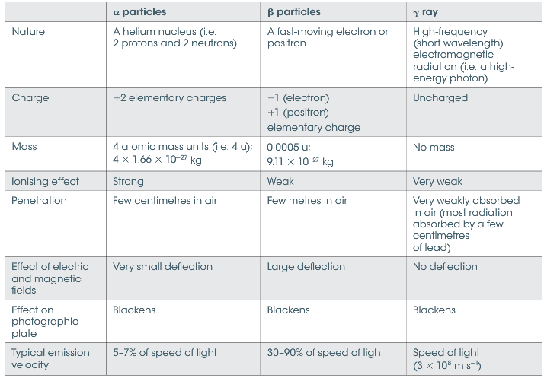

Radiation | Symbol | Charge | Structure | Nuclide | Strength | Stopped by
Alpha |  |  | Like a helium nuclei from nucleus of atom. |  | low
Beta |  |  | High speed electron from nucleus of atom |  | medium
Gamma |  |  | Electromagnetic  Radiation. |  | high
PP 3.3 p 62-6 3.3 Review p 67

Writing Nuclear Equations:

Nuclear Symbols
neutron
protons
alpha particle (helium nucleus) or
beta particle (high speed electron) or
positron or
gamma radiation

Writing Equations

- Natural reactions are ones that occur spontaneously to stabilise an atom.
- Artificial reactions are ones that occur due to bombardment by a particle.

- When balancing equations, the sum of the mass numbers on the left hand side must equal the sum of the mass numbers on the right hand side, likewise, the sum of the atomic numbers on the left hand side must equal the sum of the atomic numbers on the right hand side.

Natural Radiation: For example, part of the decay series for Uranium.

- Formation of thorium-234 from uranium- 238 releasing radiation.
what is X?
Mass number missing is 4, atomic number missing is 2 = so an alpha particle is given off.

This process is alpha decay.

- Thorium-234 then naturally decays to protactinium-234 and a radiation.
what is Y?
Mass number missing is 0, atomic number missing is -1 = so a beta particle is given off.

This process is beta decay – more precisely, beta minus decay.

${}_{11}^{22}{Na→ {}_{10}^{22}{Ne+ {}_{+1}^{0}e}}$ is an example of beta plus decay.

- Often, the release of beta particles is associated with the release of a tiny particle called a neutrino.
- e.g. when carbon-14 decays to nitrogen-14

$${}_{6}^{14}{C→ {}_{7}^{14}{N+ {}_{-1}^{0}{e+ \overline{υ}}}}$$

Artificial Radiation: For example, bombardment of a nitrogen-14 atom with alpha particles to produce oxygen-17 and what?

what is Z:
Mass number missing is 1, atomic number missing is 1 = so a proton is given off.

- Exercises
1. Write the nuclear equation for the transmutation of radioactive radium-226 into radon-222.

2. A radioactive bismuth isotope emits a beta particle. Write the full nuclear equation.

3. Molybdenum, is used to produce Technetium-99 which is commonly used in nuclear medicine. Write the nuclear equation.

4. Excited Technetium-99, is injected into the body to act as a tracer emitting gamma radiation. Write the equation.

- What is X in each of the following: symbol and name
1.
2.
3.
4.
5.
6.
7.
8.
9.
10.
11.

Decay Series

- Many products of radioactive decay are not yet stable and are themselves radioactive.
- U-238 (radioactive) will decay to Pb-206 (stable) over many steps. This will take many millions of years to occur.
- The process is outlined in a decay series.
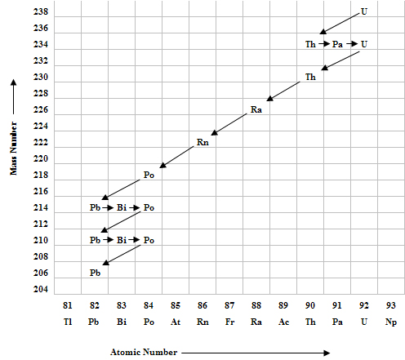

The Philosopher’s Dream – turning Lead into Gold

- A cyclotron is a machine that can accelerate charged particles to very high speeds enabling them to be smashed into atoms and by analysing the results, understand more about the structure of the atom.

- By using a cyclotron or other types of particle accelerators (a linear accelerator (or linac); a betatron or a synchrotron), Physicists have produced many artificial radioactive elements.
- Neptunium and plutonium were the first artificial elements made.
- So as you can see, one element can be changed to another and in fact, lead can be changed to gold – unfortunately, the cost to do so is much greater than the value of the gold produced – so much for the philosopher’s dream!!
.

Popcorn Experiment – An introduction to activity and half-life
- When popcorn is cooked you never know when a particular corn kernel will explode. Explain how the popcorn experiment demonstrates the unpredictability of radioactive decay (and enjoy the radiation product).

Main Points:

Each species of radionuclide has a half-life which indicates the rate of decay
This includes applying the relationship

Activity and Energy
- The activity of a radioactive sample is defined as the number of nuclei which decay each second. The unit of activity is the Becquerel (Bq) 1 Bq = 1 decay or disintegration per second

- The activity of a radioactive sample cannot be affected by any physical or chemical means.
- However, the activity will diminish with time as it is dependent on the number of undecayed nuclei left in the sample.
- As the radioactive sample decays it releases energy each decay.

- A radioisotope with a very long half life has an activity of 8.00 kBq. As the material has a very long half-life you can assume that the activity will not change appreciably over a year. Each decay of the isotope releases 1.60 x 10⁻¹³ J of energy. Calculate the amount of energy absorbed in one year. (1 year = 365 days)

Radioactive Half-Life
- Radioactive decay is a spontaneous and random process. This means that we cannot predict which particular nuclei might decay at a given instant.
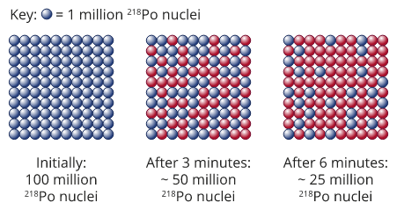
Decay of ²¹⁸Po over two half-lives showing how only 25% of original radioisotope remains after two half-lives.

- However, when we consider even a small sample of a radioactive isotope, containing many billons of atoms, a very definite pattern of decay becomes evident.
- The actual rate of decay depends on the type of nucleus and upon the number of atoms present. This rate is unaffected by external conditions such as pressure, temperature or chemical agents.
- The rate of decay of radioactive isotopes varies greatly. To compare decay rates it is best to consider the time taken for half of a radioactive sample to decay to a new element.

- We can define half-life as the time required for a given amount of radio-nuclides to spontaneously decay to half of the original amount.

- The original sample is changed into a new substance by the emission of a particle such as an alpha particle or a beta particle. Consider the following example.

- Radon-222 has a half-life of 3.8 days. If you start with 10 grams of radon, , after 3.8 days you will only have 5 grams left. At the same time though you will now have 5 grams of a new element, Polonium, . The sample would also have emitted alpha particles.

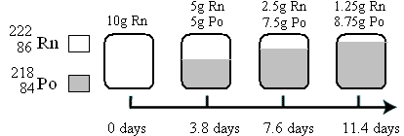

- All radioactive isotopes decay at a constant rate which is unique for that element.
- The rate of decay is also directly proportional to the stability of the isotope - the larger the half-life, the more stable the isotope.
- Consider technetium-99m which has a half-life of six hours. It is far less stable than say carbon-14 which has a half-life of 5730 years.
- At the same time carbon-14 is far less stable than uranium-238 which has a half-life of 4.5 billion years.

- The rate of decay can be shown graphically and that as each half-life elapses, the original sample is reduced by one half and the new elements being formed increases by the same amount.

- The graph shows the decay of a sample over 12 hours. Half-life curves are always exponential graphs. From an activity of 1000 to 500 in 2 hours to 250 in 4 hours to 125 in 6 hours etc.
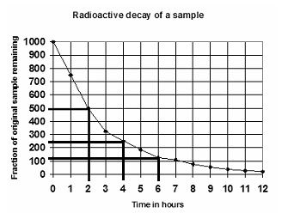

- To find the half-life. Go down the y-axis until half of the total activity, in this case 500, then rule across until you reach the curve of the graph. Rule down to the x-axis and this is the half-life. In this case, the half-life is 2 hours which is confirmed by the subsequent half life times.

- Find the half life in the following graphs:
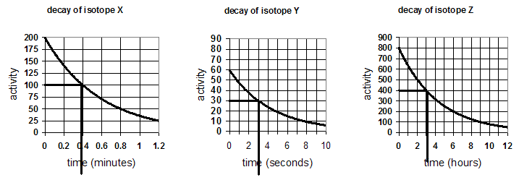

- It can be easily seen that after many half-lives a radioisotope will be reduced to a very small fraction of its original amount.
- In fact, after 10 half-lives a radioisotope will have been decayed to a point that is no longer considered a potential hazard.
- This is very important in the field of hazardous waste processing. Various waste products may have very long half-lives on the order of tens, hundreds, or even thousands of years leading to disposal problems.
- While other waste products may have short half-lives of hours, days or months in which disposal is no longer a real problem. This type of waste can be thoroughly decayed over a ten half-life program and then just treated as normal waste and disposed of accordingly.

Use of Half-Life in Archaeological Dating
- The property of radioactive decay has been used for some time in dating ancient artefacts.
- One method uses the half-life of carbon-14, although this is only useful for artefacts that were once living. All living organisms have a known ratio of concentrations of radioactive carbon-14 to non-radioactive carbon-12 within their body (this is the same as the atmosphere).
- Once the organism dies, it no longer takes in carbon-14 and that already in the organic material starts to decay to carbon-12 at a predictable rate. By comparing the ratio of carbon-14 to carbon-12, it is possible to determine how old the organism is.

- For example: If an organism such as a tree contained 1.0 g of carbon-14 while it was living, then after 5730 years it would contain half that amount, or 0.5 g of carbon-14.
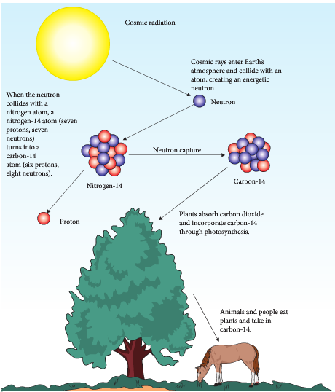
- This method of dating using carbon-14 is only useful for organisms or artefacts that are biological by nature and on the order of tens of thousands of years old.

- One problem with this method however is the assumption of a constant carbon-14 to carbon-12 ratio throughout time. Unfortunately this is not the case and this can cause a significant error factor.
- Data collection from the rings of long-lived trees (on the order of thousands of years) shows that the carbon-14/carbon-12 ratio has changed with time.

- Carbon-14 is produced when cosmic rays from space collide with atoms in our atmosphere to release neutrons.
- These energetic neutrons collide with nitrogen atoms in the atmosphere to create C-14.

$${}_{0}^{1}n+ {}_{7}^{14}{N→ {}_{6}^{14}{C+ {}_{1}^{1}H}}$$

Calculating Half-life
- The half-life of a substance is the time taken for half of that substance to decrease to one half of its original amount (to transmute to a new substance).
- This could mean half of the amount (N) or half of the mass (m).
- This relationship can be shown as:

$N= N_{0} (1/2)^{n}$ where: N_{o} = original amount of the substance;
N = current amount
or N = N₀ x (0.5)^{n} n = number of half-life periods that have elapsed.

or $\frac{N_{0}}{N}= \frac{1}{2^{n}}$

also and

or $n= \frac{t}{t_{1/2}}$ and $t_{1/2}= \frac{t}{n}$ t = total time, t_{1/2} = half life, n = number of half lifes

NOTE: The mass m of mass of a sample remaining after n half-lives can be found mathematically using:

m = m₀ (½)^{n}
where m = mass of radioactive sample remaining m₀ = initial mass of radioactive sample n = number of half-lives elapsed
- The half-life of a substance is also the time taken for the activity of a substance to decrease to one half of its original activity. This relationship can be shown as:

A = A₀ (½)^{n}
where A = activity of radioactive sample remaining A₀ = initial activity of radioactive sample n = number of half-lives elapsed

Example
A sample of radioactive material has a half-life of 15 minutes. If the original mass of the radioisotope is
40 g, what will the mass of the sample be after 75 minutes?

= $\frac{75}{15}=5$ or $n= \frac{t}{t_{1/2}}= \frac{75}{15}=5$

N₀ = 40 g N = N₀ x (0.5)^{n} m₀ = 40 g m = m₀ x (0.5)^{n}
n = 5 = 40 x (0.5)⁵ OR n = 5 = 40 x (0.5)⁵
N = ? = 40 x 0.03125 m = ? = 40 x 0.03125
= 1.25 g = 1.25 g

- The half-life of 99^{m}Tc is 6 hours. 25 g of this isotope is required for medical use at a location 18 hours away from where the isotope is prepared. How much of the isotope should be prepared?

Example
A sample of Radon-222 has a half-life of 4.20 days. If the original activity was 3.50 MBq, what will the activity be after three half lives

A₀ = 3.50 MBq A = A₀ x (0.5)^{n}
n = 3 = 3.5 x (0.5)³
A = ? = 3.5 x 0.125
= 0.4375 MBq A = 0.438 MBq

- The half-life of Iodine-131 is 8 hours. If the activity of a sample is 416 kBq, how long will it take to fall to 104 kBq?

- If the original activity of a sample is 21.0 kBq and it has a half-life of 3.00 days, how much will be left after 12.0 days?

- Another way of writing the above equation is shown below. This re-arrangement of the formula can be used when you need to find n.

- Half-life of Tc-99m is approximately 6 hours.
- A sample of Tc-99 has an activity of 8.0 x 10³ Bq. How many hours should it take for its activity to drop to 5.0 x 10² Bq?

- If it takes 18 hours for the sample to reach a medical clinic for use, what is the minimum amount that must be transported to the medical clinic if 0.2 g is required for immediate injection?

- If 8.0 x 10³ Bq is injected into the patient, what is the activity after one and a half days?

- The half-life of Iodine-131 is 8 hours. If the activity of a sample is 416 kBq, how long will it take to fall to 104 kBq?

- After an animal dies it no longer takes in Carbon-14, so that the ratio of C-14 (radioactive) to C-12 (not radioactive) gradually decreases. C-14 undergoes β-decay and has a half-life of about 5730 years. The decay rate of C-14 in a living animal is around 15 decays/minute per gram of carbon. An archaeologist has a bone fragment with a mass of 330 g from the site of an ancient human settlement. The β-decay rate from the whole bone is 620 decays/minute. What is the approximate age of the bone?

An alternative method for finding half-life

- Example:
In 3 hours, the activity of a sample of a radioactive element falls from 480 to 30 kBq. What is the half-life of this element?

Solution:
Firstly, as we must be dealing with a number of half-lives, convert the hours to minutes so time = 180 min.

We know that the activity will reduce by half each half-life so now draw a simple table which reduces the activity by half each time until the required activity is reached

Activity (Bq) | 480 | 240 | 120 | 60 | 30
Number of half-lives | 0 | 1 | 2 | 3 | 4

As there are three half-lives, the time for one half-life must be the total time divided by the number of half-lives:

so the half-life is 45 minutes

- Example:
A radioactive element has a half-life of 15 minutes. If you start with a 40 g sample of this element,
a. how much of the original radioisotope will remain after 1.25 hours and
b. how many half-lives is this?
c. the total mass of the sample that remains.

Solution:
Firstly change the 1.25 hours to minutes to match the half-life. 1.25 hours = 75 minutes. Again set up a table as shown but now we need to compare the mass to the half-life instead of the activity.

Mass radioactive part of the element (g) | 40 | 20 | 10 | 5 | 2.5 | 1.25
Half-life | 0 | 1 | 2 | 3 | 4 | 5
Addition of half-life times (minutes) | 0 | 15 | 30 | 45 | 60 | 75

From the table you can see that
a. 1.25 g of radioactive element remains
b. number of half-lives is 5
c. total mass of sample is still 40 g (see note below)

NOTE:
The total mass of the actual sample DOES NOT change as the radioactive element is turning into another element which still means the total mass is the same.

- A hospital in Perth needs 12 μg of the radioisotope technetium-99m, but the specimen must be ordered from a hospital in Sydney. If the half-life of 99^{m}Tc is 6 hours and the delivery time between hospitals is 30 hours, how much must be produced in Sydney to satisfy the Perth order?

- Do the following using the method you prefer:

- The activity of a radioisotope changes from 6000 Bq to 375 Bq over a period of 60 minutes. What is the half-life of this element?

- A sample of iodine-131 was measured to have an activity of 832 Bq. The half-life of iodine-131 is 8 hours. How much time will it take for the activity to fall to 52 Bq?

- Sodium-24 has a half-life of 15 hours. If a sample of this radioisotope has an activity of 10 million decays per second now, determine its activity in 5 days time. (This is best done using the formula rather than a table.)

- One product of nuclear power plants is the isotope caesium-137, which has a half-life of 30 years. How many years will it take for the activity of a sample of 137-caesium to reduce to 1/8th of its original value?

- C-14 is formed in the upper atmosphere by the interaction of nitrogen and cosmic rays. Living creatures breathe in C-14, dead ones don’t. The half-life of C-14 is 5730 years. One gram from a modern wooden spoon is tested and found to give, on average, 0.26 Bq. One gram of carbon is obtained from the tomb of Hemaka in Egypt. Over a one-hour period 480 counts are registered.
- How many Becquerel’s does this correspond to?

- What date does this suggest for Hemaka’s tomb?

- After an animal dies it no longer takes in Carbon-14, so that the ratio of C-14 (radioactive) to C-12 (not radioactive) gradually decreases. C-14 undergoes β-decay and has a half-life of about 5730 years. The decay rate of C-14 in a living animal is around 15 decays/minute per gram of carbon. An archaeologist finds an animal bone which has 200 g of carbon. The β-decay rate from the whole bone is 748 decays/minute.
- What is the equation for the β-decay of C-14?

- What is the approximate age of the bone?

- A newly-discovered cave containing human bones of the cave man era. Living matter with an equal amount of carbon had 8.0 times as much carbon 14 as the bones. Taking the half-life of carbon-14 as 5730 years, find the approximate age of the bones.

PP 3.4 p 68-73 3.4 Review p 74
Alpha, beta and gamma radiation have different natures, properties and effects.

Ionising ability and Penetration of Alpha, Beta and Gamma Radiation:
- Ionisation is the ability to dislodge electrons from an atom turning them into ions. Penetration ability is how far they will move through the material or human body.
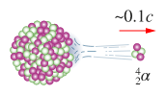

Speed and structure of an α
particle

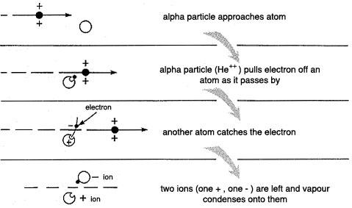
- Alpha radiation is very large and slow moving, causing it to interact with most atoms it encounters.
- It also has double positive charge,
- These two factors cause the alpha particle to dislodge electrons from atoms of the material it is travelling through and turns these atoms into ions.
- Alpha particles are highly ionising.

- Eventually, the alpha particle will pick up two electrons and turn into a helium atom.
- This can happen in less than 2 cm of air (or a sheet of paper) and as a result, alpha particles have a high ionising ability but low penetration abilities.
- Exposure to alpha radiation from outside the human body is relatively safe as the radiation can’t penetrate the skin.

- However, if an alpha emitting source is breathed in or ingested (for example radon gas), the large particle can cause ionisation of molecules in the body and reactive ions such as H⁺ or OH⁻ can take part in chemical reactions that interrupt the normal function of the cell.
- While the destruction of a small number of molecules in the body may not be serious, damage to the DNA molecules can cause permanent, serious damage and result in cancerous growths.

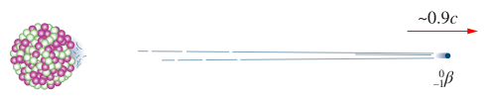
Speed and structure of a β particle.

- Although Beta particles have a negative charge, they are repelled by the negative electrons surrounding an atom and continue their journey through the material or human body.
- They do not remove electrons as readily as alpha particles so have a medium ionising ability but can penetrate skin and travel about 2 cm into the body.
- Beta particles can be stopped by thin sheets of metal.

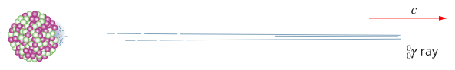
Speed and nature of γ radiation.

- Gamma radiation has no charge or mass and travels at a high speed.
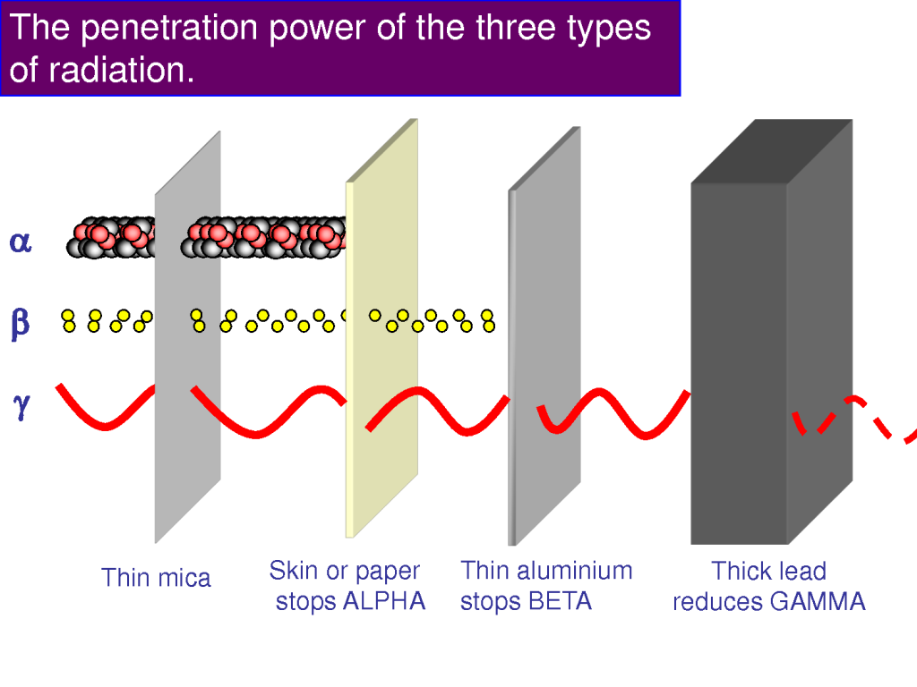
- They rarely interact with atoms so have a low ionisation ability.
- They can, however, easily penetrate most material and the human body so have a high penetrating ability.
- Gamma radiation is best stopped by very thick, dense materials like lead or concrete.

Radiation Detectors
There are four main types of radiation detectors: Geiger counters, Cloud chambers, Scintillation counters and Dosimeters.

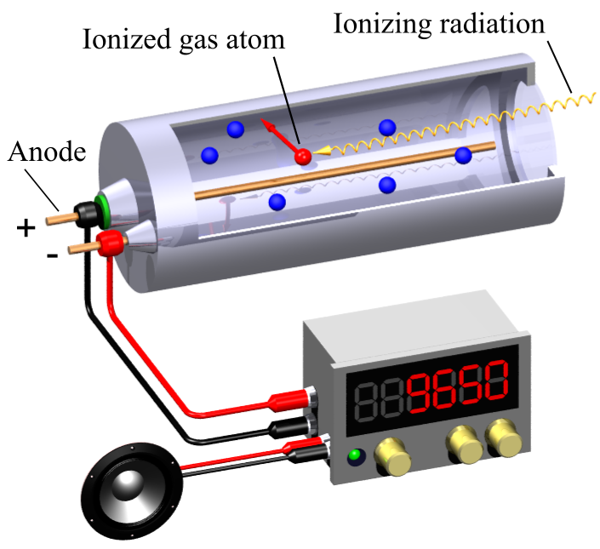
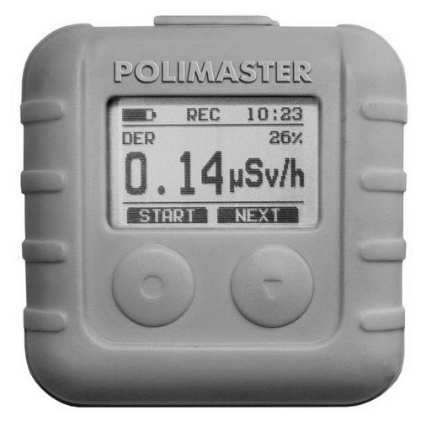
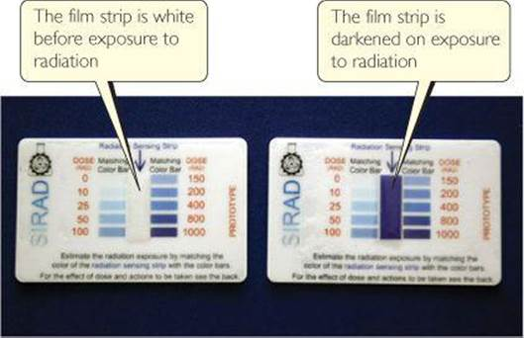

Ionising Radiation
- Ionising Radiation is when α, β or γ strike an atom with enough energy to remove one or more electrons from the outer shell of an atom causing it to become charged.
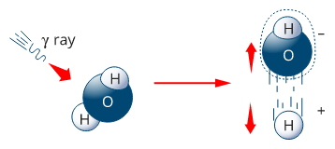
Water molecule being ionised

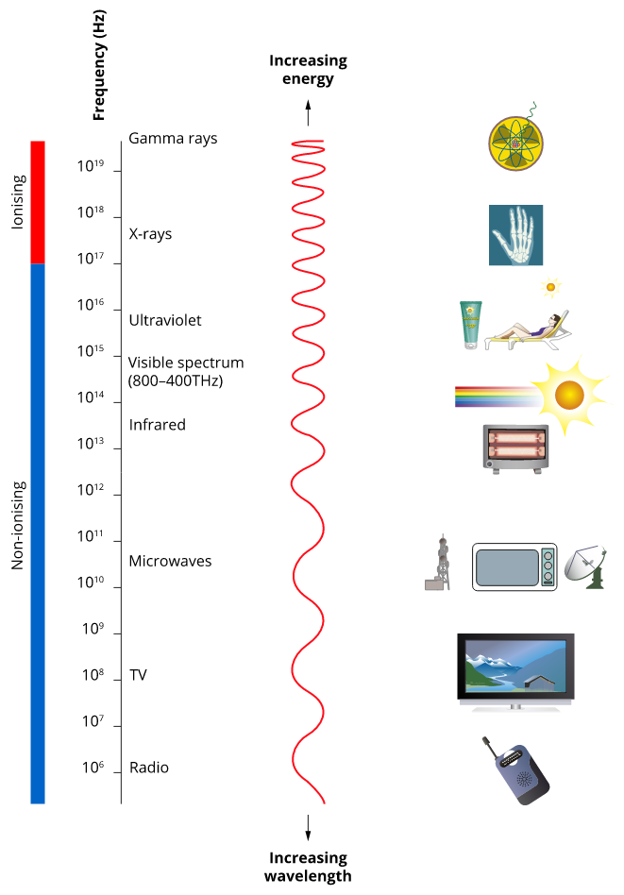
The electromagnetic spectrum consists of ionising and non-ionising radiation.

WSG 2.1 p30-43 Q’s1-14 p58-9

Uses of Ionising Radiation:

- Ionising radiation has many applications but care must be taken as it is hazardous to human health.

Industrial uses:
- Radiography by means of gamma or x-rays
- Gauges e.g. level indicators or thickness gauges

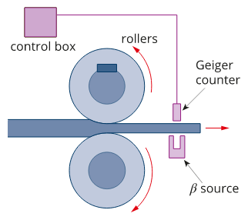
Beta emitters are used to monitor metal sheet thickness.

- Use of ionization of gases by radiation e.g.
- preventing build-up of static electricity in production of paper, plastics, synthetic textiles, etc.
- smoke detectors
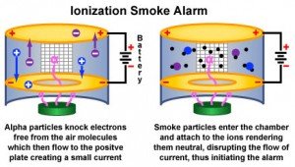

- radioactive tracers for industry e.g. finding holes in tubes or to lubricating oils in motors

Medical uses:
  - Sterilization of medical hardware or food.
  - Enhancing mutations to produced new or improved species.
  - Insect sterilization to control pests
  - Radiation therapy to treat tumours
  - Tracers in nuclear medicine.

Radioisotopes (Radioactive Isotopes)

What are they?
- Radioisotopes are a radioactive form of an element which differs in mass from the more stable form.
- Radioisotopes break up spontaneously emitting high energy particles.
- Examples are carbon-14 (which breaks down to nitrogen-14 and is often used in dating ancient artefacts), nitrogen-13 and oxygen-15.
- Some radioisotopes can be artificially produced by bombarding stable nuclei with neutrons.
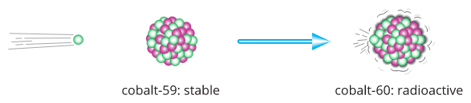

Where does the radiation come from?
- Experiments by Rutherford and Soddy in the early 1900’s helped them to discover the origin of these radiations.
- They showed that the radiation came from inside the atom; from its tiny central nucleus.
- The nucleus of a radioactive atom is unstable and can suddenly break up, throwing out high-speed particles and radiation.
- The radiation we detect is a result of these nuclear events.
- Radiation comes from two main areas: cosmic radiation from space (H nuclei, He nuclei, proton and neutrons) and terrestrial radiation from Earth.
- While many elements have isotopes, the majority of naturally occurring radioisotopes have an atomic mass above 208.
- Radioisotopes are unstable and break down to more stable forms over a period of time, some of them forming new elements.
- Alpha and/or beta particles and/or gamma radiation can be emitted during this process.

Uses for Radioisotopes
Some radioisotopes are also ionising radiation so they often have similar uses:
Industry:
- Gaining information that can’t be obtained using other methods thus helping to improve productivity.
- Radiography, gauges and mineral analysis often using long life sources
- Flow tracing and mixing measurements using short lived radioactive material.
- Sterilisation of medical supplies and irradiation of foods to extend shelf life using gamma radiation.

Medicine:
- Using nuclear medicine to provide diagnostic information on the body or to treat specific problems.
- Radiotherapy to treat some medical conditions e.g. cancer
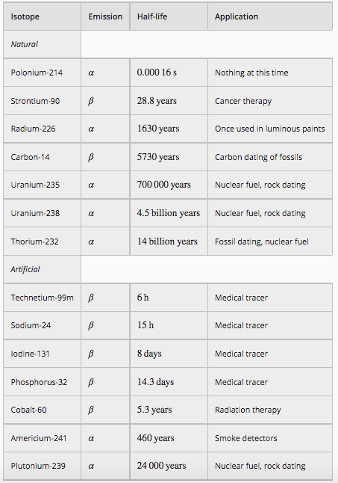

Tc-99 has a short half-life (~6 hours). When introduced into the body it can spread out and collect at certain locations. As it decays it releases radiation that can be detected.

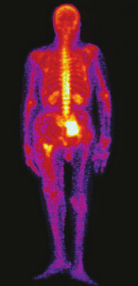

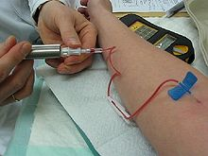
Applications of radioisotopes
In Medicine:
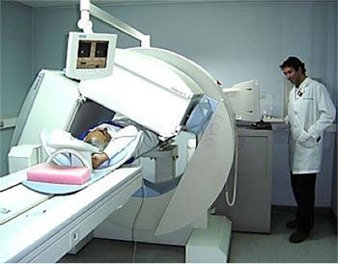
- X-rays will give a lot of information about bones but radioisotopes imaging can be used as an alternative.
- An example is a runner who has pain in both shins. A possible cause is a stress fracture in the tibia.
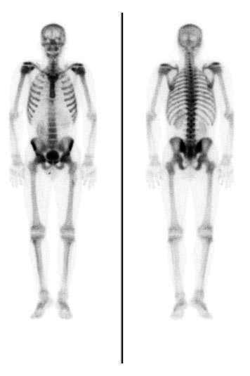
- A nuclear technologist gives an injection of 99-Tc^{m} (an excited form of Technetium-99 which emits gamma radiation for a short duration - ) then after several hours, the runner undergoes a bone imaging.
- If the bone has been damaged, it will have undergone higher bone growth and this will show up as a stronger image on the screen. This is also used for arthritis and abnormal bone growths.

Use of radioisotopes as Tracers
- Radioactive materials can be used as a tracer in many situations; in industry, in agriculture and in medicine.

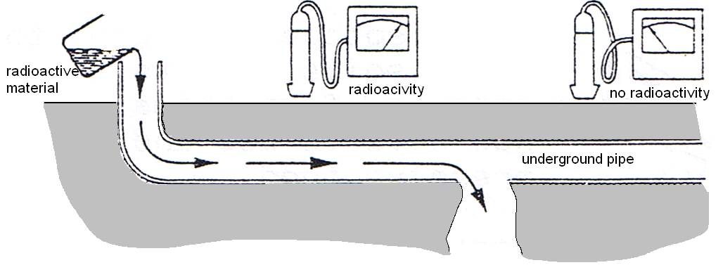
Tracers In Industry
- The diagram shows how a radioactive material such as gamma radiation (why not alpha or beta?) can be used to find a leak in an underground pipe.

- Use the diagram to explain how the leak is traced and explain why only gamma radiation is used.

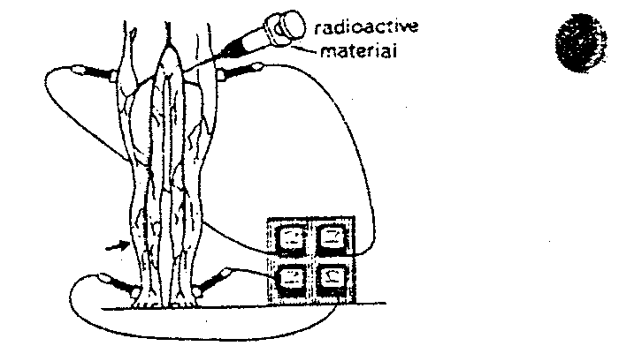
Tracers In Medicine
- Radioactive materials can be injected into the body and their movement traced.

- The diagram shows how a radioactive material (in this case, Sodium-24, a beta emiiter) is injected into the bloodstream. The radioactive materials can be circulated through the whole body. The patient has a blockage in a large blood vessel (arrowed), which affects the circulation of the blood.

- A short half-life radioactive material is injected into the bloodstream. The bottom right Geiger counter has a low reading.

- Explain how the blockage can be located.

- Some radioactive materials given to patients will collect in a diseased part of the body. The diseased tissue then emits radiation. A camera that can detect radioactivity can be used to “photograph” the position of a tumour by the radiation it will emit.

- What type of radiation would be used? Do you think the radioactive material given to the patient will be a strong or a weak source of radiation? Justify your answers?

Tracers in Agriculture – Animals:

- Radioisotopes are used to study soils, plants, insects, farm animals and new ways to use and preserve food. Agricultural researchers might need to know how long a mouthful of hay takes to reach a bull’s stomach.

- How can the use of radio isotopes help them to find this out?
The diagram shows how a scientist can determine which insect is the best for control of the local garden pest - aphid.

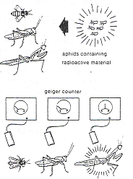
- To enable biological control of insects the helpful insect must first be identified before they can be used. (Diagram on the right.)

- Which insect was found to be the most “helpful”?

- How was it identified?

- What use might be made of this information?

Tracers In Agriculture - Plants
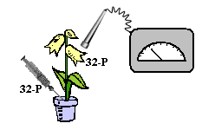
- Phosphorus-31, a non-radioactive isotope, is part of the chemical processes of plants for growth and reproduction. Phosphorus-32, on the other hand, is a radioactive isotope of phosphorus but as it is the same element, it is used in the same way by the plant.
- Phosphorus-32 is injected into the roots of the plant. The Geiger counter is then used to detect the progress of the phosphorus-32 throughout the plant helping biologist to gain a more in-depth understanding of how the plant grows and reproduces.

- How would a biochemist use radioactive carbon to trace the path of carbon atoms in the photosynthesis process of green plants?

Measuring Iron Ore
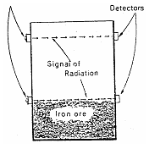
- The diagram shows the location of two radiation detectors used to indicate the amount of iron ore in an ore bin. The detector arrowed (top left) is shown in close-up (bottom left). The radiation comes from a source housed on the other side of the bin.

NOTE: the source housing and detectors are drawn much enlarged.
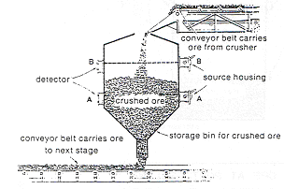

The diagram shows how a level gauge works. The source housing contains some radioactive material. A beam of radiation is directed towards a detector on the other side of the bin.

- In the diagram above, only detector B registers radiation, detector A does not. Why?

- How would level indicator A let workers know if the top conveyor belt was delivering ore too slowly?

- How would workers know from the level indicators if the bottom became blocked?

Principle of the Thickness Gauge.
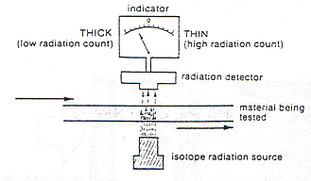
- The diagram to the left shows a radiation source and detector being used to control the thickness of a rolled sheet of plastic (or paper, or metal).

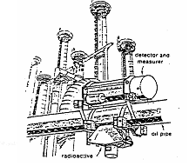

- The diagram on the right shows how the density of oil flowing through oil pipes at a refinery is checked by a radiation device. (The sewage treatment plant in the Perth metropolitan area uses similar equipment to check the density of sewage.)

- Explain how each of these devices works.

- In your own words, compare and contrast the three types of radiation in areas such as their mass, speed, transmutation ability, ionization potential, penetration into human body, etc.

Property | Alpha | Beta | Gamma
What are they
Mass
Charge
Speed
Transmutation ability
Ionisation potential
Penetration ability - human
Stopped by

NOTE: When finding the mass number for nuclides in Nuclear Physics DO NOT use the mass number in the periodic table. These mass numbers are for all isotopes of that element and in Nuclear Physics you are finding out information on just one of the isotopes an element may have.

- The symbols for four different nuclei follow. Determine the number of protons and neutrons in each nucleus and name the element the symbol represents:
Nuclide | Name | Atomic Number | Mass Number | Number of Protons | Number of Neutrons

- What do we called the last two examples and explain why:

- Name the three types of radioactivity emitted during nuclear decay processes. Explain, in relation to their properties, how you would tell them apart.

- Nuclear radiation is given off by an atom when its nucleus undergoes decay. How do the mass number and atomic number of the decaying nucleus change when each of the following forms of radiation is emitted?

- a beta particle

- an alpha particle

- gamma radiation

- Complete the following table using only the information given:
Nuclide  (complete) | Mass number | Atomic number | Number of neutrons | Number of protons
 |  | 6 | 14
 |  | 82 | 124
 |  |  |  | 26
 | 27
 |  |  | 138

WSG 2.2 p44-50 Q’s15-25 p59-60

FALLOUT IN THE FOOD CHAIN – A story of nuclear pollution
The measurement of absorbed dose and dose equivalence enables the analysis of health and environmental risks
This includes applying the relationships
Absorbed dose = E/m

Dose equivalent = absorbed dose x quality factor

On 25th April 1986, there was a nuclear accident in a reactor at Chernobyl in Russia. Some radioactive fuel rods exploded when the fission chain reaction ran out of control. The rise in power that resulted, together with white hot fragments of the core, produced vast quantities of steam that blew the lid off the reactor and spread radioactive debris around the area. This set off fires and created a very high radiation field around the plant. The core, now open to the air, was left burning and further chemical explosions occurred as water reacted with zirconium pressure tubes to make hydrogen and carbon monoxide.

Nuclear reactors contain many ‘fission products’ that come from the nuclear reactions. With the shielding gone, these began to get into the atmosphere. First were inert radioactive gases such as xenon-133. They were swept high into the atmosphere by the heat of the fires and blown north by the wind towards Finland and Sweden. Inert gases do not dissolve or react and so cannot enter the food chain. However, anyone out in the open as the cloud passed overhead would be irradiated by it. Other fission products that got into the atmosphere were iodine-131 and caesium-137. These are volatile elements that were released in the form of fine dust particles or vapour. They were swept up as a radioactive plume into the air and within five days had been spread by winds over most of Europe, Scandinavia and Britain. The iodine and caesium were washed out of the clouds by rain that fell during those five days, producing radioactive hot spots on the ground. In Britain the highest concentrations of radioactivity were found on high lands such as Wales, Cumbria and Scotland.

The radiation enters the food chain when it is taken up by vegetation that is then eaten by sheep or cows. It appears in milk within a few days and in the meat of the animals after some months. Iodine-131 has a relatively short half-life of eight days but still has time to enter our bodies through radioactive milk. Caesium has a half-life of 30 years and is much more persistent. It can contaminate vegetation and animals for many years at great cost and waste. The Lapp reindeer herders of Northern Sweden are an example of a group who have been particularly hard hit by the fallout. Rain fell over parts of their homeland as the cloud passed and deposited caesium-137 on the lichen that the reindeer eat. Lichens have no roots and take all their nourishment from the air thus absorb up to three times as much radiation as other plants and having no roots, cannot pass it on to the ground. Many thousands of reindeer became radioactive from eating the lichen and their meat had to be condemned. The Lapps traditional life-style and livelihood have been disrupted and will not return to normal until the contaminated lichen has been eaten or has lost its radioactivity. This could take a generation.

NOTE: In December of 2000 the last of the four reactors was closed down and while the chemical explosion at Chernobyl devastated the plant and the area around it, it will do no further damage. The effects of the nuclear explosion however were global and will remain a danger to health for many years to come.

What does all this mean?
- So why did the radiation have such an effect? To understand this we need to understand the effects of radiation on us and how we can measure it.
- Firstly, we need to recall what ionizing radiation is. Ionizing radiation is radiation produced when a heavy atom splits.
- If this radiation comes in contact with the cells in your body, it can remove an electron from an atom thus creating a charged ion – hence the name ionizing radiation.
- Most forms of nuclear radiation are considered to be ionizing radiation, as are X-rays which are high energy, very short wavelength electromagnetic radiation.

- There are three main ways to measure the effect of radiation:
  - The Becquerel (Bq) measures the activity or the number of decays or disintegrations per second. It gives no indication about the effect of the radiation on us.
  - The Gray (Gy) measures the energy absorbed by us per kilogram of our body weight but doesn’t consider the ionizing effect of the type of radiation we receive.
  - The Sievert (Sv) measures not only the amount of radiation per kilogram but also takes into account the ionizing effect of the type of radiation, and its ionizing effect on human tissues. This unit is used when considering radiological protection.

Measurement of Radiation

Activity:
- The activity of a radioactive sample is defined as the number of nuclei which decay or disintegrate each second. The unit of activity is the Becquerel (Bq) and 1 Bq = 1 decay per second.
- We can use the relationship: where : A = activity,
ΔN = number of decays and
Δt = change in time (in seconds)
Also,
- The activity can tell us about the stability of the radiation source and the half-life (higher activity means less stable and shorter half-life) but little else.

Absorbed Dose:
- The absorbed dose is the radiation damage to cells determined by the amount of energy absorbed by the cells.
absorbed dose = energy absorbed
mass of absorbing tissue

- The S.I. unit for absorbed dose is the GRAY (Gy). 1 Gy = 1 joule of energy absorbed per kilogram.
- While this tells us the amount of energy the cells receive, it doesn’t tell us the ionizing effect of the radiation and hence the degree of damage to human cells, tissues and organs.

Dose Equivalent:
- Dose equivalent is a useful concept when comparing the effects of different amounts of radiation of the same type.
- For example, 1 Gy of alpha radiation will have a greater effect on the cells than 1 Gy of beta radiation.
- Dose equivalent equals the absorbed dose x QF, where QF is a quality factor allowing for different effects of ionising rations on tissues of various kinds.

dose equivalent = absorbed dose x QF

- The S.I. unit for dose equivalent is the SIEVERT (Sv).

- The table below shows values of QF, you will always be given any required values in assessment tasks.

Radiation type | QF
X-rays, γ-rays and β particles  Low energy neutrons  High energy neutrons and protons  Alpha particles. | 1  3  10  20

- A laboratory technician accidentally swallows a radioisotope. He records the activity of another sample and finds that there are 1.62 x 10⁵ decays per hour. The material swallowed has a long half-life and you can assume therefore that the activity will not change appreciably during the physicist’s lifetime. Each decay of the isotope releases 3.60 x 10⁻¹² J of energy into the body and that the radioisotope is not eliminated from the body.

- Calculate the activity of the radioisotope.

- Calculate the amount of energy absorbed in one year. (1 year = 365 days)

- If the technician has a mass of 70 kg, calculate the absorbed dose in one year.

- The technician knows that the sample he swallowed emits alpha particles. Should he be concerned? Explain. (You will need to show calculation of dose equivalent to justify your answer.)

- A radioactive material has a half-life of 2.45 x 10⁻³ s. What percentage will be left after 1.47 x 10⁻² s?

Radiation Sources
- Radiation strikes our bodies even without nuclear explosions. About 15% is from man-made sources but 85% is from natural radiation which results in a background radiation.
- This background radiation is divided into two main groups: cosmic radiation from space (about 14% of the radiation we receive) and terrestrial radiation from the Earth.

- Terrestrial background radiation can come from the following sources:
- fallout from nuclear explosions
- emissions from nuclear power stations and radioactive waste
- medical uses – treatment of disease and research
- use in factories – production lines to check if packets are full or thickness of materials. Also for sterilization of food.
- use at home – luminous watches, gun sights, exit signs, gas mantles, smoke detectors
- from the food we eat and from water sources
- building materials and soil
- radon gas (more of a problem for colder climates)

- In Australia, we receive about 1.5 mSv a year and about 50% of this is gamma radiation due to our active, outdoors lifestyle.
- This radiation delivers an average dose of 1.9 mJ of energy to each kilogram of our bodies every year and long term, about 2000 people a year may get cancers from its effects.

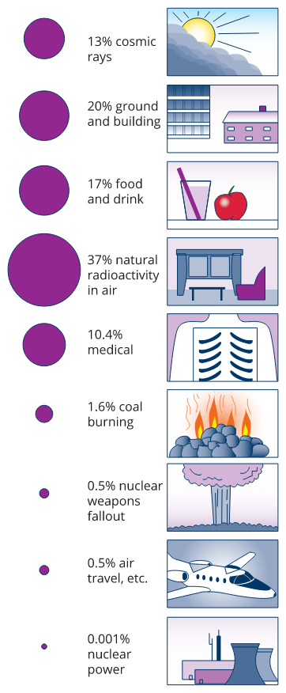
Everyone is exposed to radiation from the environment.

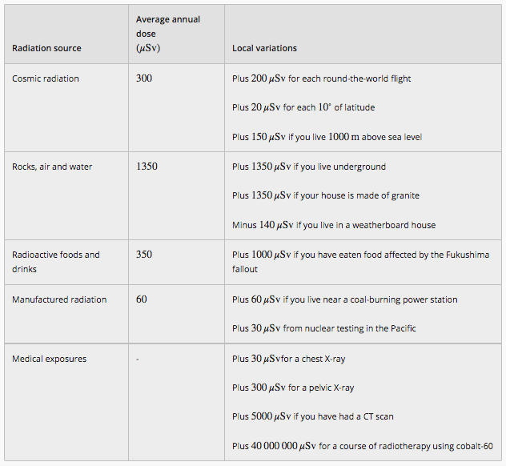

Physiological Effects of Ionising Radiation
- The effect of radiation on our bodies is due to the damage or changes that occur at the cellular level. The magnitude of this effect is proportional to the radiation dose equivalent received.
- The symptoms from a large radiation dose to the body become evident within a few days or weeks.
- These include nausea and vomiting and a general unwellness (called radiation sickness).

- Some part of the body are more sensitive to ionising radiation than others, the most sensitive being bone marrow, the reproductive organs, the eyes, digestive system and circulatory system.

- Lower doses of radiation may produce effects which only become apparent after several months or even years.
- These include a reduced life expectancy, the development of leukaemia or tumours and cataracts on the eye lens.
- Genetic damage, if it occurs, may not be apparent for several generations. The table below gives some physiological effects of ionising radiation.

Approximate Dose Equivalent (Sv) | Effects
<0.25 | no observable effects
0.5 | slight temporary blood changes
1.0 | nausea, fatigue, vomiting
2.0-2.5 | fatally possible
5.0 | about 50% of victims die
10.0 | all victims die

Safety and Shielding
- Radioactive material must be handled with care. Don’t touch sources or point them at the body, handle with tongs held at arm’s length.
- Always keep in lead-lined boxes when not in use. Remember, do not take risks with this invisible radiation, the damage it causes many not show up for several years, or until you have children.
- Shielding is an important way to protect yourself.

- The underlying principles of radiation protection from external sources is known as the TDS Rules:
- Decrease Time of exposure.
- Increase Distance from source.
- Use Shielding where necessary.
PP 3.5 p 75-83 3.5 Review p 84
Einstein’s mass/energy relationship relates the binding energy of a nucleus to its mass defect
This includes applying the relationship

Atomic Mass Unit

- To enable us to do calculations about mass and energy in nuclear processes, we need to use common units.
- In SI units, mass is in kilograms and energy in joules but because of the very small values associated with the atom, we use atomic mass units (amu or u for short) for mass and electron volts (eV or MeV) for energy.

PARTICLE | ATOMIC MASS (u)
electron | 0.00055
Proton | 1.00728
Neutron | 1.00867
Atomic Mass Unit:
- One atomic mass unit, u, is the mass of 1/12th of carbon-12.
- 1 u is equal to 1.6606 x 10⁻²⁷ kg. The table shows the mass of the particles in the atom.

Electron Volt:
- An electron volt is a unit of energy.
- It can be thought of as the energy that a proton or electron could gain when it moves through a potential difference of 1 volt – hence one electron volt.
- One electron volt (eV) is equal to 1.60 x 10⁻¹⁹ J.
- It is common to use mega-electron volts (MeV) which is 1.60 x 10⁻¹³ J.
- One atomic mass unit, u, also equals 931 mega-electron volts. 1u = 931 MeV.

Mass Defect and Binding Energy
- If you were to add the individual masses of protons and neutrons in an atom, it would be greater than the actual mass of the atom.
- When the parts of a nucleus come together, an energy force in the nucleus holds them together and prevents the protons from repelling each other.
- This energy comes from the conversion of mass into energy when protons and neutrons combine, and is called the binding energy, E_{b}.

binding energy = mass defect x (speed of light)².

- This mass difference between the “mass of the components in the nucleus” and the “mass of the nucleus itself” is called the mass defect, m_{d}.

mass defect = (mass of neutrons and protons) - (mass of nucleus)

so combining these two ideas,

E_{b} = m_{d} c² where: E_{b} = the binding energy in joules (J)
m_{d} = mass defect in kg.
c = speed of light, 3.0 x 10⁸ ms⁻¹
FOR A SINGLE ATOM
- Example: Calculate the binding energy of a lithium-7 nucleus, in joules and MeV.
There are two methods you can use depending on the question asked, however each requires the mass defect and you will be given all the masses.

mass defect = (mass of neutrons and protons) - (mass of nucleus)
m_{d} = [(3 x mass proton) + (4 x mass neutron)] - (mass of )
= [(3 x 1.67 x 10⁻²⁷) + (4 x 1.68 x 10⁻²⁷)] - 1.165 x 10⁻²⁶
= 5.01 x 10⁻²⁷ + 6.72 x 10⁻²⁷ - 1.165 x 10⁻²⁶
= 8.0 x 10⁻²⁹ kg

Finding energy in Joules  binding energy per nucleus,  E_{b} = m_{d} c²  E_{b} = 8.0 x 10⁻²⁹ x (3 x 10⁸)²  E_{b} = 7.2 x 10⁻¹² J  1 MeV = 1.6 x 10⁻¹³ J  x MeV = 7.2 x 10⁻¹² J  x = 45.0 MeV | Finding energy in MeV  1.66 x 10⁻²⁷ kg = 1 u  so mass in u =  u = 0.04819 u  1u = 931 MeV  Therefore MeV = 0.04819 x 931  = 44.9 MeV

FOR AN EQUATION

NOTE:
When dealing with an equation, DO NOT convert the atoms in the equation into individual protons and neutron as the individual protons and neutrons have a GREATER mass than the atom. WHY?

- Example 2
In the sun, hydrogen atoms combine to make helium in the process of fusion. In this process, energy is released. One of the reactions is shown. Determine the binding energy release for this reaction in joules and MeV.

ANSWER: Here we use the total mass of the left hand side subtract the total mass of the right hand side using the masses given for each atom (not the masses of individual protons and neutrons).
= mass of the left hand side – mass of the right hand side (mass defect)
= 1.67 x 10⁻²⁷ kg m_{d} = (mass ) - (mass )
= 3.34 x 10⁻²⁷ kg = (1.67 x 10⁻²⁷ + 3.34 x 10⁻²⁷) – 5.00 x 10⁻²⁷
= 5.00 x 10⁻²⁷ kg = 1.00 x 10⁻²⁹ kg

In joules:  E_{b} = m_{d} x c²  = 1.00 x 10⁻²⁹ x (3.0 x 10⁸)²  E_{b} = 9.00 x 10⁻¹³ J | In MeV  mass in u =  = 6.024 x 10⁻³ u  MeV = 6.024 x 10⁻³ x 931  = 5.61 MeV

- Do the following question using both methods.
A common reaction in nuclear fission power plants is , calculate the energy released from this reaction in joules and MeV.
= 3.902 x 10⁻²⁵ kg
= 2.339 x 10⁻²⁵ kg
= 1.526 x 10⁻²⁵ kg
= 1.674 x 10⁻²⁷ kg

Binding Energy per Nucleon
- While it is interesting to look at the binding energy of an atom, a more useful measure of stability is the binding energy per nucleon as this tells us how much energy must be applied to remove each nucleon from the rest of the nucleus.
- (Binding energy per nucleon of an atom is the binding energy of that atom divided by the total number of protons and neutrons.

- So for the example on page 32, the E_{b} per nucleon = 44.9 ÷ 7 = 6.41 MeV per nucleon. If the binding energy per nucleon is high, the nucleus is stable and difficult to pull apart. Atoms with mass numbers close to 60 have the highest binding energy per nucleon as shown in the graph.

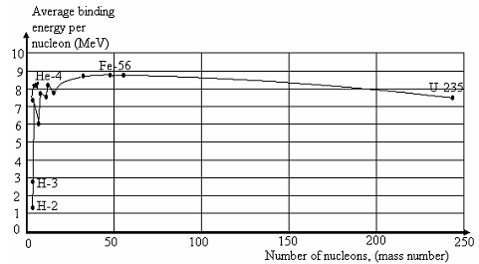

- Uranium will often decay into two similar daughter products, each about half the mass of the uranium. The uranium atom is less stable than the two daughter atoms as uranium has a lower binding energy per nucleon than the two daughter atoms.
- Helium, on the other hand, has a high binding energy per nucleon and is very stable, which helps explain why alpha particles are emitted when large atoms break up as the bonds between the helium nucleons are very strong.

- In fission, energy is released when a larger, more unstable atom decays to a smaller atom/s often emitting radiation as explained on the next page.
- In nuclear fusion, two smaller atoms come together to make a larger atom. As this is the opposite of nuclear fission, it may seem unusual that energy is released.
- Again this relates to the binding energy per nucleon. If the new atom in fusion has a higher binding energy than the two atoms which joined, energy will be released.

Atomic mass units (amu)
- An atomic mass unit (amu) is a unit of mass used to express atomic and molecular weights, equal to one twelfth of the mass of an atom of carbon-12.
- It is often more convenient to perform calculations using amu.

- In a nuclear fission power plants ,
Calculate the energy released from this reaction in joules and MeV.

= 235.04393 amu
= 140.91441 amu
= 91.92616 amu
= 1.00867 amu

- determine the mass defect in amu.

- convert the mass defect in amu to kg – 1 u = 1.6606 x 10⁻²⁷ kg.

- find the energy in J – E = mc².

- convert J to eV – 1 MeV = 1.6 x 10⁻¹³ J

Alternatively:

- mass defect in amu.

- convert amu to MeV – 1u = 931 MeV

- convert MeV to J – 1 MeV = 1.6 x 10⁻¹³ J

- Binding Energy Problems – Answers at back of booklet
Use the atomic masses found on page 2 of this workbook.

1. What is the binding energy per nucleon in MeV for the following atoms involved in nuclear
energy:
a. U-238 nucleus b. b. He-4 nucleus
c. Fe-56 (one of the most stable atoms) (Fe = 55.934939 u)

2. The oxygen atom O has an isotope, O. Find the binding energy of each nucleus and thus
determine which is more stable.

3. Calculate the energy released from one decay of U-238.

4. There are about 6.023 x 10²³ atoms in 235 g of pure uranium 235. The bomb dropped on
Hiroshima had approximately twice this mass of uranium.
- Calculate the energy release for one atom of U-235 in joules and MeV
- How much energy was released by the Hiroshima bomb in joules and MeV?

5. H-3 and H-2 will fuse to form He-4 and one neutron.
- Work out the mass difference.
- How much energy will one fusion reaction release in joules and MeV?
- The energy released from one fission reaction of U-235 is about 200 MeV. How does this compare with the energy released in a fusion reaction?

PP 4.1 p 91-4 4.1 Review p 95
PP 4.3 p 107-8
Alpha and beta decay are examples of spontaneous transmutation reactions, while artificial transmutation is a managed process that changes one nuclide into another.

Transmutation of Isotopes and Decay Series
- As previously discussed, when a nucleus emits a particle such as an alpha or beta particle, the number of protons can change and a new element would be formed, this is called transmutation (alpha removes two protons and beta results in a change in the number of protons and neutrons).
- Transmutations can be natural, for example radioactive decay of uranium, or artificial, for example bombarding nucleus with alpha or beta particles, or with neutrons.
- Sometimes the new element is also unstable and it decays. This can create a decay series.
- The original source is called the parent and the new products are called the daughter products. It is important to remember that radioactive decay is a random process as can be shown by the popcorn experiment.

Neutron-induced nuclear fission is a reaction in which a heavy nuclide captures a neutron and then splits into smaller radioactive nuclides with the release of energy.

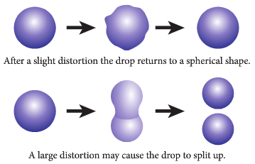
Fission and Fusion
Nuclear Fission:

- Fission is the splitting of the nucleus of an atom to produce two relatively equal daughter products together with a large amount of energy. One possible reaction is:

(or 3.2 x 10⁻¹¹ J)

- There are millions of atoms in one kilogram of urainium-235 which could produce 8 x 10¹³ J of energy.
- As you can see, the reaction above needs a neutron to start it but it then produces 2 neutrons so one reaction can cause several more reactions leading to a self-sustaining series of reactions called a chain reaction.
PP 4.1 p 88-90

Nuclear Fusion:
Nuclear fusion is a reaction in which light nuclides combine to form a heavier nuclide, with the release of energy.

- Fusion involves the joining of two light atomic nuclei to form one heavier nucleus.
- This process also produces a large amount of energy as is shown by the energy produced from our sun and other stars. A typical reaction in our sun is shown below:

- This reaction releases about 1.6 x 10¹⁴ J per kilogram of helium produced and the products are safe for humans and the environment unlike nuclear fission.

- Fusion reactors are currently not possible due to the high temperatures needed (50 -100 x 10⁶ ⁰C), the ability to confine a sufficient quantity of the reacting nuclei to release useful energy and the fact that the heated gas is in a state of matter called plasma, which cannot be contained by ordinary materials, only within a strong magnetic field. Research into fusion reactors is ongoing.

A fission chain reaction is a self-sustaining process that may be controlled to produce thermal energy, or uncontrolled to release energy explosively if its critical mass is exceeded.

Chain Reactions and Critical Mass Configuration

A Neutron Induced Chain Reactions
- Fission is the splitting of an atom into smaller parts with the release of neutrons, as is shown below.
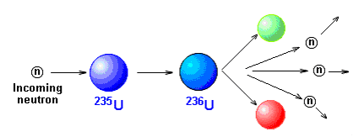

- Positively charged particles would be repelled by a nucleus while uncharged neutrons are able to smash into the nucleus.
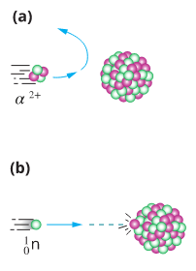


- 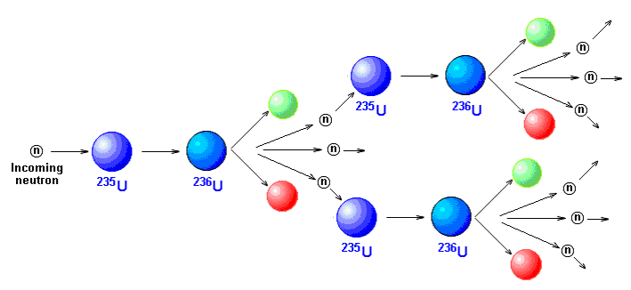Now these released neutrons can in turn cause further fission reactions as shown. If on average, two of these released neutrons were to cause further fissions, then the number of fission events would increase as the series 1, 2, 4, 8, 16, 32, 64, …… a runaway explosion!
- This is known as a self sustaining neutron induced chain reaction.

- Fortunately, such a chain reaction does not easily occur due to a variety of factors:
- Neutrons may simply escape from the material without hitting any nuclei. Remember, nuclei are an extremely small part of an atom.
- Neutrons may be absorbed by uranium-238 nuclei which rarely undergo fission. Only 0.7% of naturally occurring uranium is the fissile uranium-235.
- Only the very slow neutrons, called thermal neutrons, are likely to cause uranium-235 to split. Fast neutrons emitted from a fission reaction are more easily captured by uranium-238.

- In a nuclear reactor, this reaction is controlled as neutrons are absorbed by control rods rather than U-235 and no explosion occurs, rather the energy produced is converted to electrical energy to run the country. 75% of France’s energy comes from nuclear reactors.

Critical Mass Configuration
- Critical mass refers to the mass of fissile material required to sustain an uncontrolled chain reaction such as that which occurs in an atom bomb.
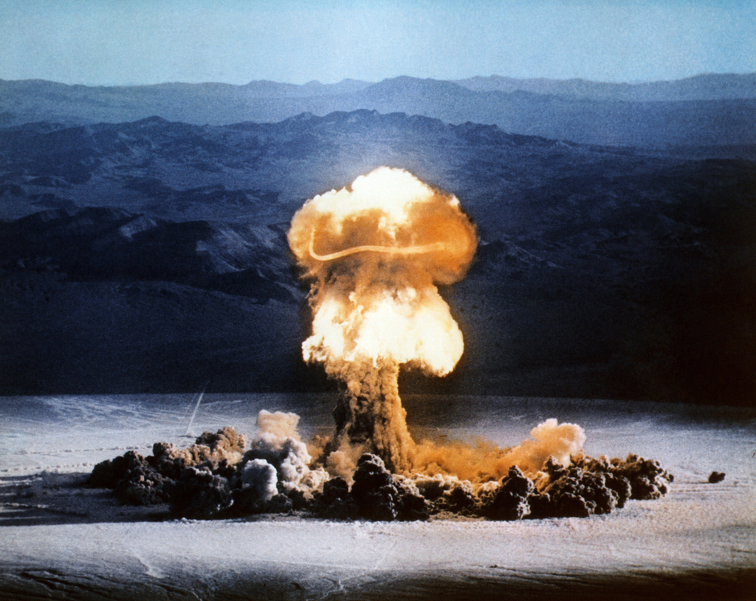
The explosion of an atomic bomb generates a mushroom cloud.

- If too little matter is present, most of the neutrons produced in a fission reaction escape from the material without interaction.
- Critical mass depends on the percentage of U-235 in a sample since uranium-238 is not fissile.
- It also depends on the shape of the mass.

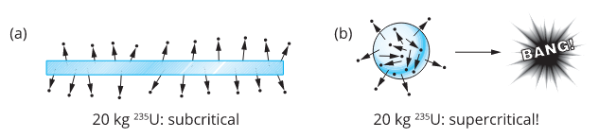

(a) Large proportion of neutrons escaping flat piece of uranium-235. (b) Greater proportion of neutrons involved in keeping chain reaction going.

- For pure U-235, critical mass is only a few kilograms, while for 3% enriched uranium it is several tonnes (enriched uranium is mainly U-238 with U-235 added ie 3% enriched uranium has 3% U-235.)

Nuclear Reactors

General elements of the Design of a Nuclear Reactor

- Fuel rods – these long, thin rods contain the pellets of enriched uranium for fission. Enriched U-235 is used to allow a sustained chain reaction.

- Moderator – this is a material that slows the neutrons to help promote fission. Fission reactions are more likely to occur when the neutron is slow moving.

- Control rods – these are a material that absorb neutrons and control the fission reaction. Without them the reaction will become uncontrollable and an explosion will occur.

- Radiation shielding – fission reactions produce gamma radiation so the reactor core needs shielding to protect the workers.

- Coolant – fission reactions produce a large amount of energy so a coolant is needed to remove this heat energy.

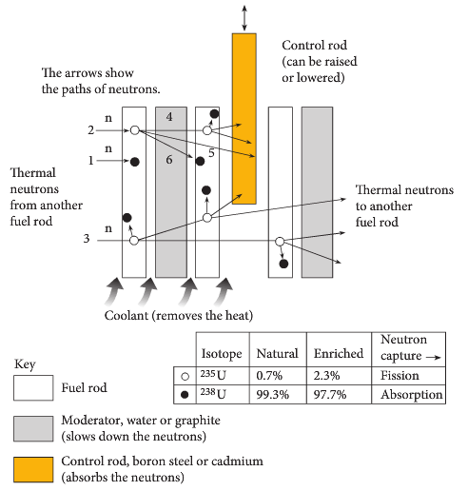


- The energy from the coolant is then passed to pipes containing water. The water is converted into steam and this steam is used to rotate the turbines which drive generators. The generators produce electricity for use in industry or homes.

- This is not unlike the production of electricity from fossil fuels where the heat energy from burning the fossil fuels is used to turn the water to steam to rotate the turbines.

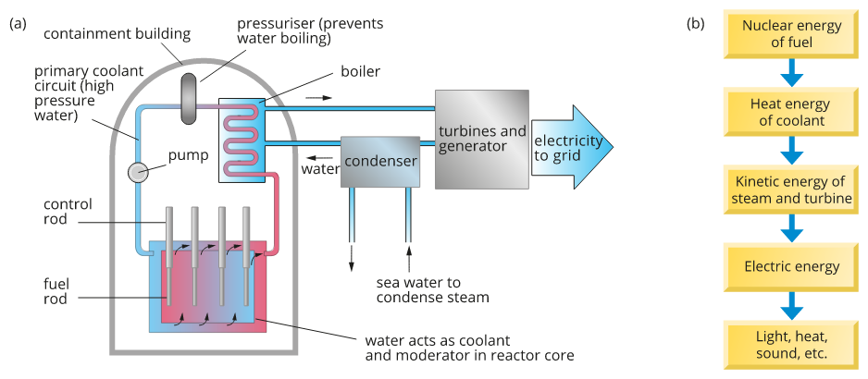
(a) Diagram of nuclear reactor; (b) energy transformations involved as reactor is used to produce electricity.

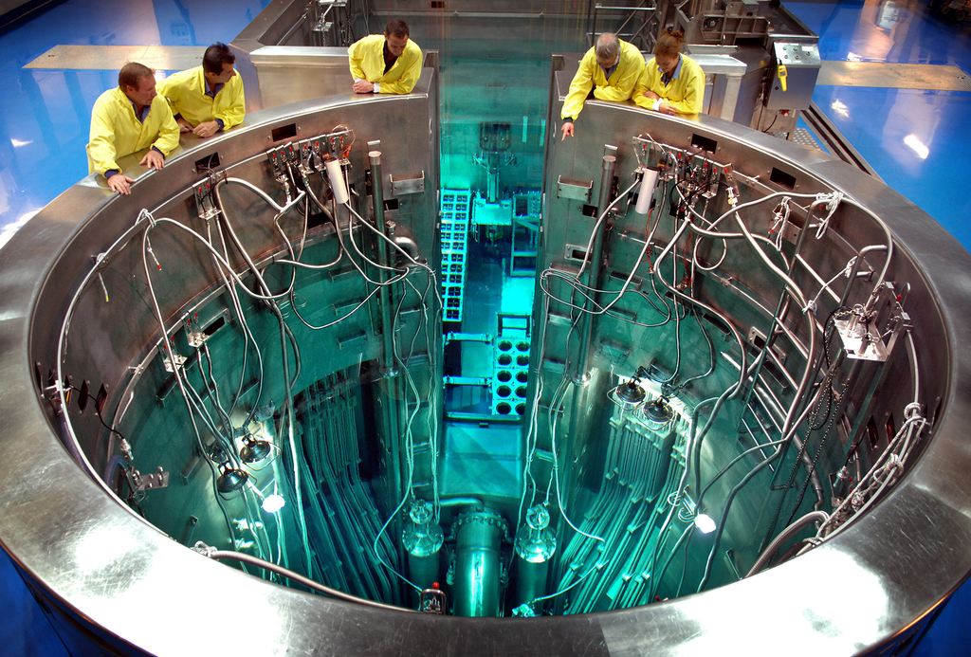
Australia's only nuclear reactor is located at Lucas Heights, a suburb of Sydney. The HIFAR (High Flux Australian Reactor) operated here from 1958 to 2007, but has now been replaced by a new research reactor known as OPAL (Open Pool Australian Lightwater reactor). About 7 kg of uranium enriched to 20 % uranium-235 is immersed in a pool of water almost 13 m deep. Radioisotopes that are used in industry and in the nuclear medicine departments of Australia's hospitals are synthesised here.

Advantages and Disadvantages of Nuclear Energy
- Some of the advantages and disadvantages of nuclear power stations and nuclear power in general.

Advantages: | Disadvantages:
- The nuclear power is a more practical, reliable, economical, cheaper energy and a safe way of energy production.  - The Earth has limited supplies of coal and oil. Nuclear power plants could still produce electricity after coal and oil became scarce.  - Nuclear power plants need less fuel than ones which burn fossil fuels. One tonne of uranium produces more energy than is produced by several million tonnes of coal or several million barrels of oil.  - Coal and oil burning plants pollute the air. Well-operated nuclear power plants do not release contaminants into the environment.  - A small amount of uranium produces a vast amount of energy.  - It doesn't produce CO₂ like fossil fuels.  - The waste is minimal. | - The Reactor has to be cooled constant.  - Workers have a risk of dying by prostate cancer  - Nuclear reactors also have waste disposal problems. Reactors produce nuclear waste products which emit dangerous radiation.  - The waste products cannot be thrown away like ordinary garbage.  - It takes a few 1000 years for materials to no longer radiate.  - The nuclear radiation harms the cells of the body which can make people sick or even kill them.  - One possible type of reactor disaster is known as a meltdown. In such an accident, the fission reaction goes out of control, leading to a nuclear explosion and the emission of huge amounts of radiation.

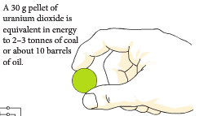

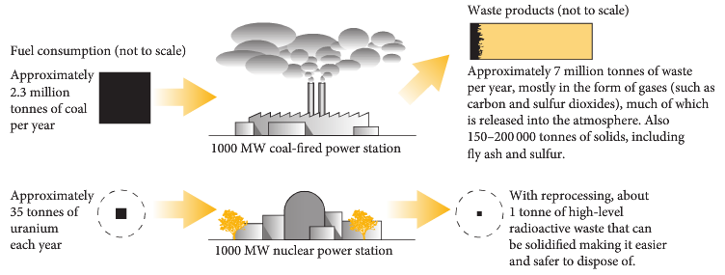

- The management of any nuclear wastes must be based on the knowledge of the behaviour of radiation.

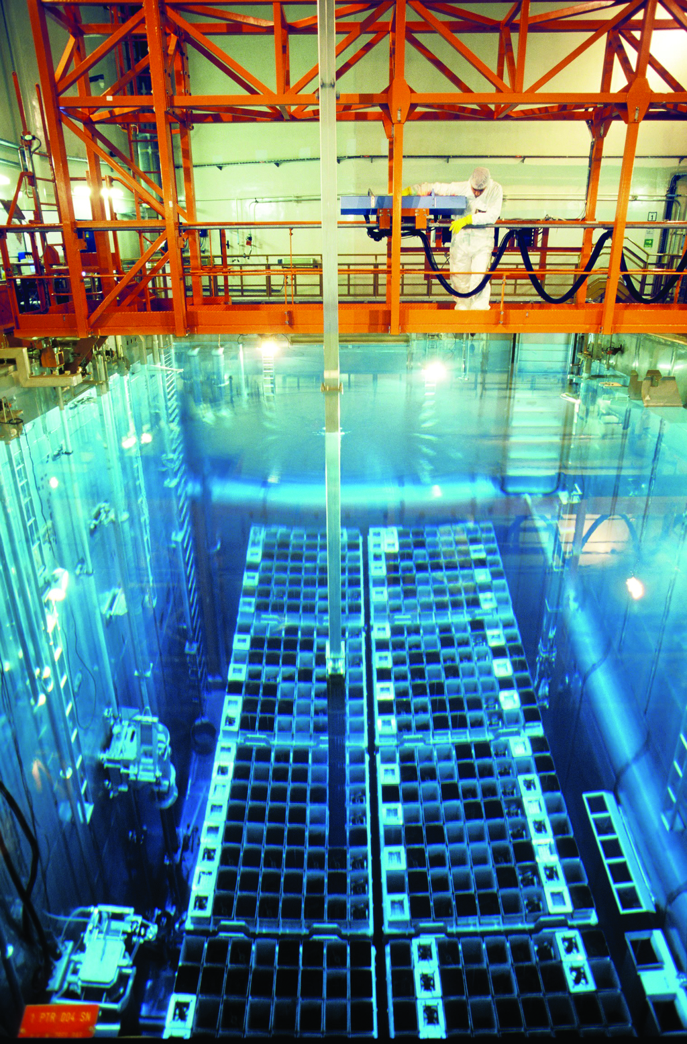

The management of nuclear waste is a significant issue for the nuclear energy industry. This is a photograph of a cooling pond used for storing spent nuclear fuel rods. Over 40% of spent fuel rods produced world-wide are permanently stored in this way. The remainder are reprocessed and the fissile material is reused as nuclear fuel, the fission products being stored permanently in underground bunkers.

PP 4.2 p 96-102 4.2 Review p102-3
More energy is released per nucleon in nuclear fusion than in nuclear fission because a greater percentage of the mass is transformed into energy.

Fusion
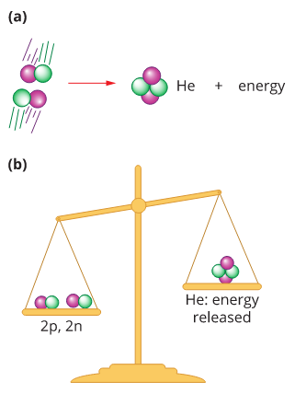
(a) When two isotopes of hydrogen fuse to form a helium nucleus, energy is released. (b) The binding energy of the nucleus appears as a loss in mass Δm which can be calculated using ΔE = Δmc².

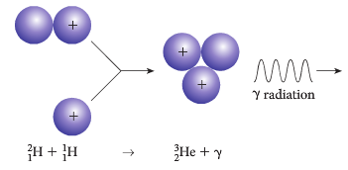

Fusion of deuterium and a proton

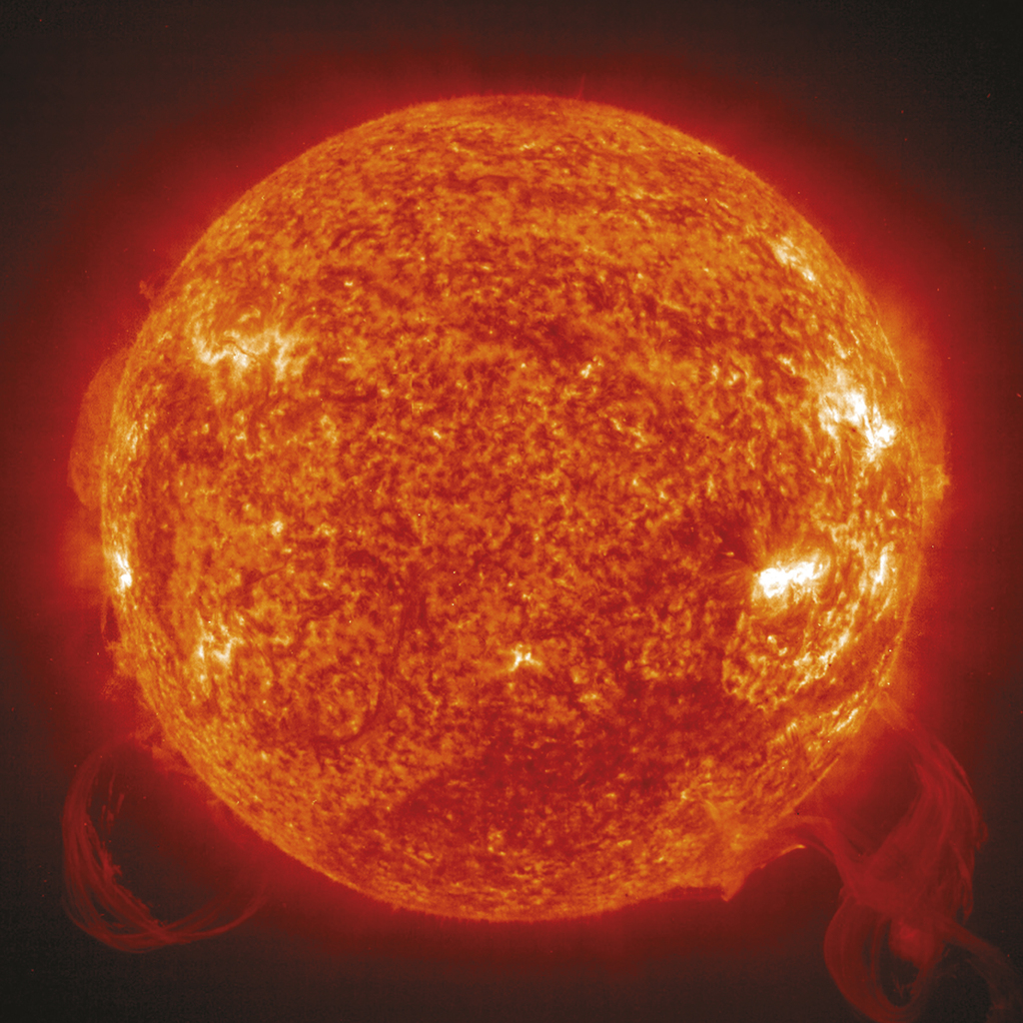
The Sun – A Natural Fusion Reactor

- Nuclear fusion is the ultimate source of the solar energy we receive every day.
- Within the sun, smaller atoms and molecules are progressively being fused to form larger molecules with the release of large amount of energy.

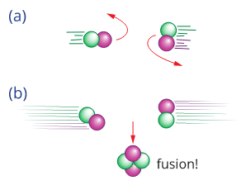

- Slow moving nuclei do not have enough energy to fuse – they are repelled.

- At very high temperatures, nuclei can get close enough to overcome the repulsive forces and the strong nuclear forces comes into effect, allowing the nuclei to fuse.

- One reaction within the Sun involves the fusing of two isotopes of hydrogen, deuterium (H-2) and tritium (H-3) to produce Helium (He-4) and a neutron.
- The difference in the mass between the reactants and the products is converted to solar energy which is the source of all energy on Earth.

- You can see therefore that nuclear fusion could be described as the ultimate energy source for mankind as deuterium, the fuel for nuclear fusion, is readily obtained from sea water.
- A great deal of energy is produced during fusion however the radioactive waste is very small. While commercial nuclear fusion reactors are still some way off, it is likely they will be common place by the next century.

Exercise:
      - Calculate the energy released from one reaction in the sun. (in joules and MeV)

      - There are roughly 1 x 10⁵⁷ particles in the Sun of which one quarter are helium atoms. Calculate the amount of energy released (in joules) in creating these helium atoms assuming, for this exercise only, all came from the reaction discussed above.

Fusion Reactors
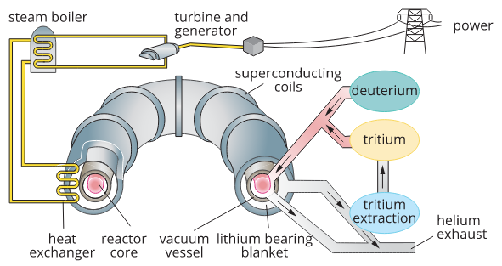
Design of experimental tokamak fusion reactor

PP 4.3 p 104-9 4.3 Review p 110 Chapter Review p 111
WSG 2.3 p51-7 Q’s26-31 p60-1

Binding Energy Problems

1. What is the binding energy per nucleon in MeV for the following atoms involved in nuclear
energy:
a. U-238 nucleus

U-238 = 92p + 146n
m_{d} = ([92 x 1.00728) + (146 x 1.00867)] - U-238
= 92.66976 + 147.26582 – 238.05079
= 1.88479 μ

E = 1.88479 x 931
= 1754.739 MeV per atom

as there are 238 nucleons, then
binding energy per nucleon = = 7.37 MeV
b. He-4 nucleus

He-4 = 2p + 2n
m = (2 x 1.00728) + (2 x 1.00867) – 4.00260
= 0.0293 μ

E = 0.0293 x 931
= 27.2783 MeV per atom

as there are 4 nucleons, then
binding energy per nucleon = = 6.82 MeV

c. Fe-56 (one of the most stable atoms) (Fe = 55.934939 u)

Fe-56 = 26p + 30n
= (26 x 1.00728) + (30 x 1.00867) – 55.934939
= 0.514441 μ

E = 0.514441 x 931
= 478.9445 MeV per atom

as there are 56 nucleons, then

binding energy per nucleon = = 8.55 MeV

You will notice that the binding energy per nucleon is greater than the previous two examples.

2. The oxygen atom O has an isotope, O. Find the binding energy of each nucleus and thus
determine which is more stable.

O-16 = 8p + 8n
= (8 x 1.00728) + (8 x 1.00867) – 15.99943
= 0.12817 μ

E = 0.12817 x 931
= 119.32627 MeV per atom

as there are 16 nucleons, then

binding energy per nucleon = = 7.46 MeV

O-17 = 8p + 9n
= (8 x 1.00728) + (9 x 1.00867) – 16.99913
= 0.13714 μ

E = 0.13714 x 931
= 127.67734 MeV per atom

as there are 17 nucleons, then

binding energy per nucleon = = 7.51 MeV

Oxygen 17 has the greater binding energy so is more stable.

3. Calculate the energy released from one decay of U-238.

m_{d} = 238.05079 – (4.00260 + 234.04360)
= 4.59 x 10⁻³ u
= 7.622154 x 10⁻³⁰ kg

E = mc²
= 7.622154 x 10⁻³⁰ x (3 x 10⁸)²
= 6.86 x 10⁻¹³ J or E = = 4.29 MeV or E = 4.59 x 10⁻³ x 931 = 4.27 MeV

4. There are about 6.023 x 10²³ atoms in 235 g of pure uranium 235. The bomb dropped on
Hiroshima had approximately twice this mass of uranium.
        - Calculate the energy release for one atom of U-235 in joules and MeV

U-235 = (92p + 143n) - 235.04393
m_{d} = ([92 x 1.00728) + (143 x 1.00867)] - 235.04393
= 92.66976 + 144.23981 - 235.04393
= 1.865577 μ
= 3.09686 x 10⁻²⁷

E = 3.09686 x 10⁻²⁷ x (3 x 10⁸)² E = 1.865577 x 931
= 2.79 x 10⁻¹⁰ J per atom = 1736.852 MeV
= 1.74 x 10³ MeV per atom

        - How much energy was released by the Hiroshima bomb in joules and MeV?

E = 2.78717 x 10⁻¹⁰ x 6.023 x 10²³ x 2 and E = 1736.852 x 6.023 x 10²³ x 2
= 3.36 x 10¹⁴ J = 2.09 x 10²⁷ MeV

5. H-3 and H-2 will fuse to form He-4 and one neutron.
              - Work out the mass difference.

m_{d} = (2.01355 + 3.01605) - (4.00260 + 1.00867)
= 0.01833 μ

              - How much energy will one fusion reaction release in joules and MeV?

E = 0.01833 x 1.66 x 10⁻²⁷ x (3 x 10⁸)² E = 0.01833 x 931
= 2.74 x 10⁻¹² J = 17.1 MeV

              - The energy released from one fission reaction of U-235 is about 200 MeV. How does this compare with the energy released in a fusion reaction?

The energy from U-235 is much greater

